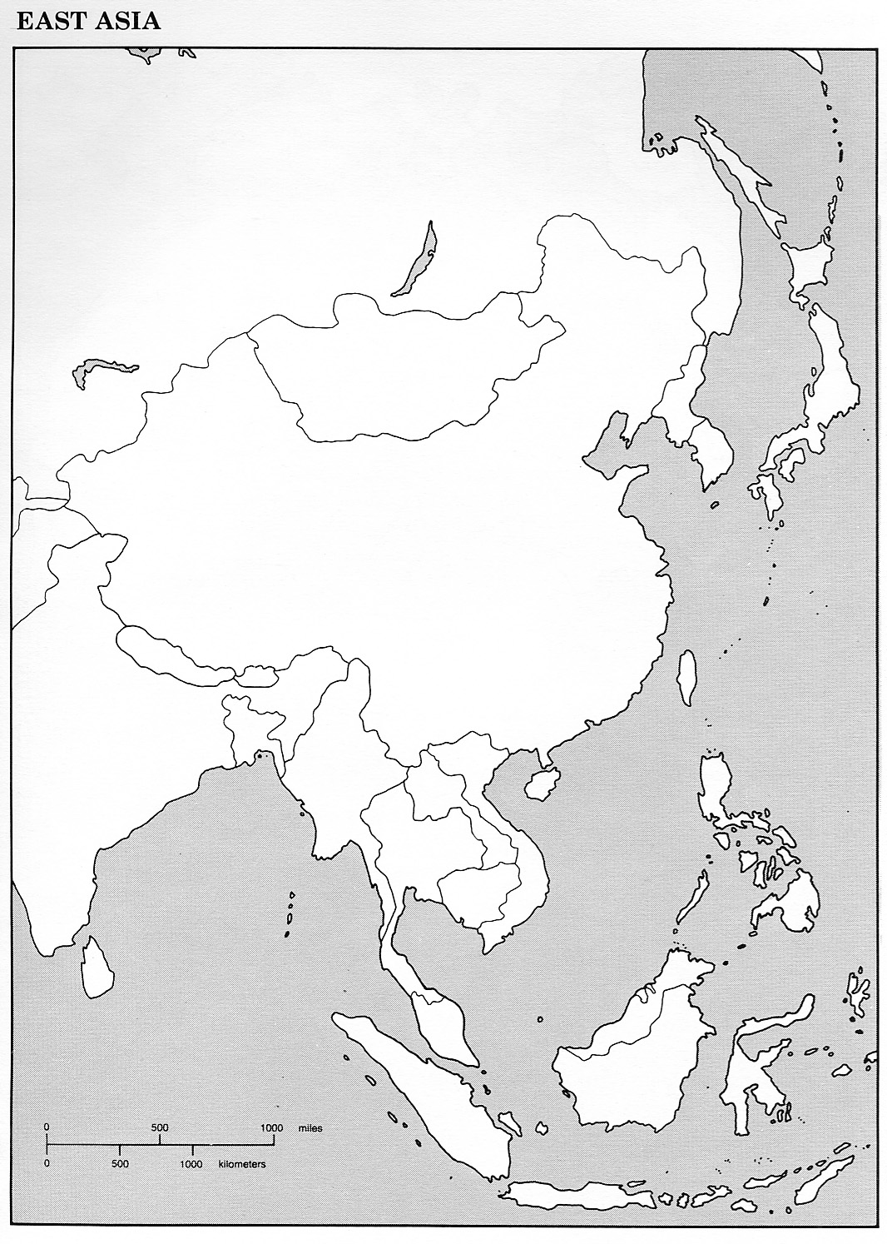
CWA: Mapping Current Events – East Asia

