CWA: Global Issues Unit – Civic Action Project – Source Reading
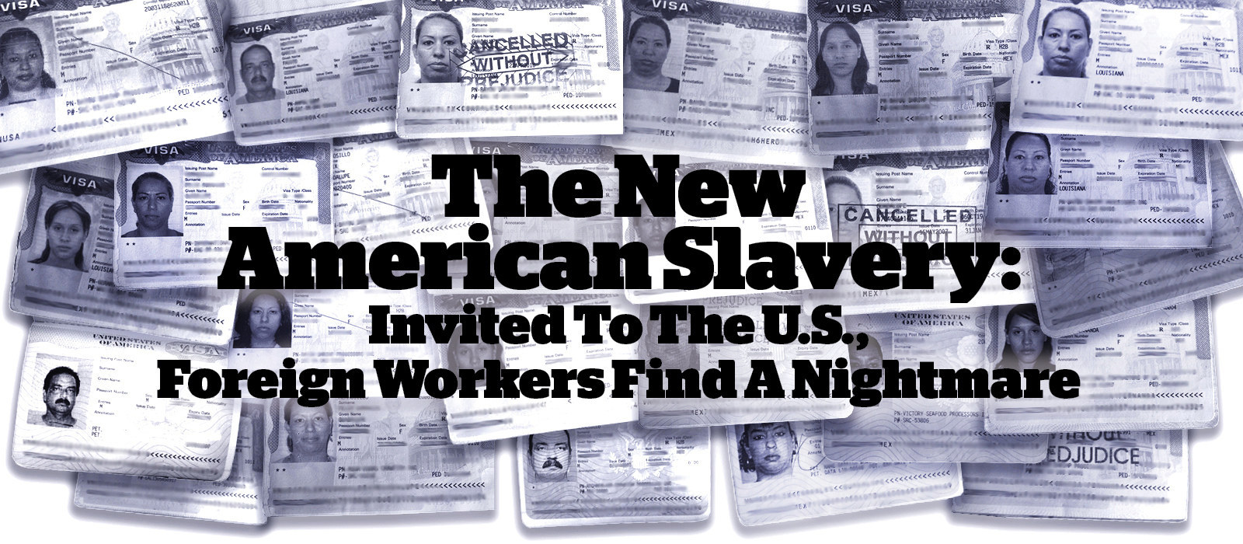
Directions: 1. Read and annotate the document. 2. Bullet point key information applicable to the branch of modern slavery that you are planning to research [use the information presented as a springboard to spur further research and Qs].
By Jessica Garrison, Ken Bensinger, BuzzFeed News Reporters & Jeremy Singer-Vine, BussFeed News Editor / 0724/2015 / Mamou, Louisiana, USA

The H-2 visa program invites foreign workers to do some of the most menial labor in America. Then it leaves them at the mercy of their employers. Thousands of these workers have been abused — deprived of their fair pay, imprisoned, starved, beaten, raped, and threatened with deportation if they dare complain. And the government says it can do little to help. This is a BuzzFeed News investigation.
MAMOU, Louisiana — Travis Manuel and his twin brother, Trey, were shopping at Walmart near this rural town when they met two Mexican women who struck them as sweet. Using a few words of Spanish he had picked up from his Navy days, Travis asked the two women out on a double date. Around midnight the following Saturday, when they finished their shift at a seafood processing plant, Marisela Valdez and Isy Gonzalez waited for their dates at the remote compound where they lived and worked. As soon as they got in the Manuel brothers’ car, the women began saying something about “patrón angry,” Travis recalled. While he was trying to puzzle out what they meant, his brother, who was driving, interrupted: “Dude,” Trey said. “There’s someone following us.” Trey began to take sudden turns on the country roads threading through the rice paddies that dot the area, trying to lose the pickup truck behind them. Finally, they saw a police car.
“I said, we’re gonna flag down this cop” for help, Travis recalled. “But the cop pulled us over, lights on, and told us not to get out of the vehicle,” Trey added, noting that the pickup pulled up and the driver began conferring with the police. An officer asked Trey and his brother for ID. From the backseat, their dates began to cry. Travis tried to reassure them. They weren’t doing anything wrong, he said, and they were in the United States. “I was like, ‘There’s no way they are going to take you away.’” He was wrong.
The man in the truck was the women’s boss, Craig West, a prominent farmer in the heart of Cajun country. As Sgt. Robert McGee later wrote in a police report, West said that Valdez and Gonzalez were “two of his girls,” and he asked the cops to haul the women in and “scare the girls.” The police brought the women, who were both in their twenties, to the station house. McGee told them they couldn’t leave West’s farm without permission, warning that they could wind up dead. To drive home the point, an officer later testified, McGee stood over Valdez and Gonzalez and pantomimed cutting his throat. He also brandished a Taser at them and said they could be deported if they ever left West’s property without his permission.
A little after 2 in the morning, they released the women to West for the 15-minute drive through the steamy night to his compound — a place where, the women and the Mexican government say, workers were stripped of their passports and assigned to sleep in a filthy, foul-smelling trailer infested with insects and mice. Valdez and Gonzalez also claimed that they and other women were imprisoned, forced to work for little pay, and frequently harassed by West, who demanded to see their breasts and insisted that having sex with him was their only way out of poverty.
These women were not undocumented immigrants working off the books. They were in the United States legally, as part of a government program that allows employers to import foreign labor for jobs they say Americans won’t take — but that also allows those companies to control almost every aspect of their employees’ lives.

Each year, more than 100,000 people from countries such as Mexico, Guatemala, the Philippines, and South Africa come to America on what is known as an H-2 visa to perform all kinds of menial labor across a wide spectrum of industries: cleaning rooms at luxury resorts and national parks, picking fruit, cutting lawns and manicuring golf courses, setting up carnival rides, trimming and planting trees, herding sheep, or, in the case of Valdez, Gonzalez, and about 20 other Mexican women in 2011, peeling crawfish at L.T. West Inc. A BuzzFeed News investigation — based on government databases and investigative files obtained through the Freedom of Information Act, thousands of court documents, as well as more than 80 interviews with workers and employers — shows that the program condemns thousands of employees each year to exploitation and mistreatment, often in plain view of government officials charged with protecting them. All across America, H-2 guest workers complain that they have been cheated out of their wages, threatened with guns, beaten, raped, starved, and imprisoned. Some have even died on the job. Yet employers rarely face any significant consequences.
Many of those employers have since been approved to bring in more guest workers. Some have even been rewarded with lucrative government contracts. Almost none have ever been charged with a crime. In interview after interview, current and former guest workers — often on the verge of tears — used the same word to describe their experiences: slavery. “We live where we work, and we can’t leave,” said Olivia Guzman Garfias, who has been coming to Louisiana as a guest worker from her small town in Mexico since 1997. “We are tied to the company. Our visas are in the company’s name. If the pay and working conditions aren’t as we wish, who can we complain to? We are like modern-day slaves.”
In a statement, the Department of Labor, which is charged with protecting workers and vetting employers seeking visas, said that the H-2 programs “are part of a wider immigration system that is widely acknowledged to be broken, contributing to an uneven playing field where employers who exploit vulnerable workers undermine those who do the right thing.”
The number of H-2 visas issued has grown by more than 50% over the past five years. Unlike the better-known H-1B visa program, which brings skilled workers such as computer programmers into America’s high-tech industries, the H-2 program is for the economy’s bottom rung, designed to make it easier for employers to fill temporary, unskilled positions. Proponents argue that it gives foreigners a chance to work here legally, send home much-needed dollars, and return to their families when the job is over. In March, the U.S. Chamber of Commerce defended the guest worker program before a Senate committee, noting that such “temporary workers are needed in lesser-skilled occupations that are both seasonal and year round,” and that aspects of the program are “critical” to “American workers, the local community, and companies that provide goods and services to these seasonal businesses.”
Tens of thousands of companies, ranging from family businesses to huge corporations, have participated in the program since it took its modern form in 1986. Employers pledge to pay their workers a set rate, which can range from the federal minimum wage to a higher “prevailing wage” that varies from state to state and job to job. As for the employees, they can only work for the company that sponsored their visa. They are legally barred from seeking other employment and must leave the country when the job ends.
For some people, such as the hundreds of soccer coaches who youth sports camps bring in every year from the United Kingdom and elsewhere, an H-2 visa offers an opportunity to make some money while spending time in another country. Many companies treat their H-2 employees well, and many guest workers interviewed for this article said they are grateful for the program. But public records and interviews reveal how easy it is for companies that sponsor H-2 visas to abuse their employees.
Many companies pay their guest workers less than the law mandates. Others pay them for fewer hours than they actually work, or force them to work extremely long hours without overtime. Some, on the other hand, offer them far less work than promised, at times leaving workers without enough money to buy food. Employers also whittle away at wages by imposing an array of prohibited fees — starting with bribes to get the jobs in the first place, which can leave workers so deep in debt that they are effectively indentured servants. Guest workers often toil in conditions that are unsafe, inhumane, or simply exhausting, wielding dangerous machinery beneath a scorching sun or standing for hours on end in sweltering factories. And at the end of their shift, many workers retire to grim, squalid quarters that might be little more than a grimy mattress on the floor of a crowded, vermin-infested trailer. For such housing, some employers charge workers extortionate rent. Though it is against the law, employers often exert additional control over guest workers by confiscating their passports, without which many foreign workers, fearful of being deported, feel unsafe leaving the worksite. Some employers extend their influence over workers to extremes, screening their mail, preventing them from receiving visitors, banning radios and newspapers, or even coercing them to attend religious services they don’t believe in. Some foremen sexually harass female workers, who live in constant fear of losing their jobs and being deported.
The world has become accustomed in recent years to hearing of guest worker abuse in countries such as Qatar or Thailand. But this is happening in the United States. And the problem is not just a few unscrupulous employers. The very structure of the visa program enables widespread abuse and exploitation. The way H-2 visas shackle workers to a single employer leaves them almost no leverage to demand better treatment. The rules also make it easy to banish a worker to her home country at the boss’s whim. And guest workers tend to be so poor — and, often, so indebted from the recruitment fees they paid to get the job in the first place — that they feel they have no choice but to endure even the worst abuses. Court documents and interviews revealed numerous cases where workers who tried to speak out said they received threats to their lives. Many others claimed they were blacklisted by employers, losing the opportunity to get jobs that, however miserable, give them more money than they could earn in their own countries.
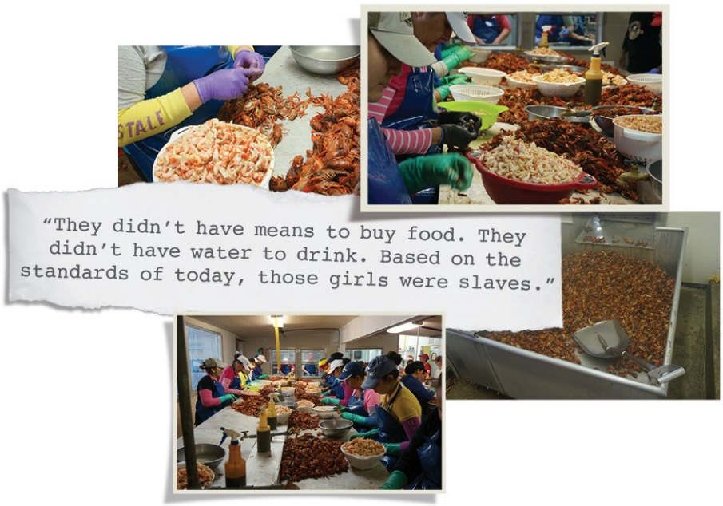
The government has been warned repeatedly over almost two decades that the guest worker program is deeply troubled, with more than a dozen official reports excoriating it for everything from widespread visa fraud to rampant worker abuse, and even calling for its elimination. Since 2005, Labor Department investigation records show, at least 800 employers have subjected more than 23,000 H-2 guest workers to violations of the federal laws designed to protect them from exploitation, including more than 16,000 instances of H-2 workers being paid less than the promised wage. Those numbers almost certainly understate the problem, as the federal government doesn’t check up on the vast majority of companies that bring guest workers into this country. The Labor Department noted in its statement that it has limited resources, with only about 1,000 investigators to enforce protections for all 135 million workers in the U.S. Still, it said, it recovered more than $2.6 million in back wages owed to roughly 4,500 H-2 workers in the 2014 fiscal year. In that year, the agency said, it found violations in 82% of the H-2 visa cases it investigated. Kalen Fraser, a former investigator for the Labor Department’s Wage and Hour Division who specialized in H-2 visa cases, said that while some companies stumble over complex rules, a substantial portion “maliciously” violate worker protection laws. “There’s a big power imbalance there, and the worst guys get away with everything.”
Route 95 between Chataignier and Mamou, Louisiana, winds through endless acres of rice paddies that teem with crawfish after the grain is reaped. The country is dead flat, and stretching to the horizon there’s little but lush fields of green, dotted with glassy brown pools beneath a heavy sky. Near a bend in the two-lane highway sits the L.T. West crawfish plant. It was there that Valdez, Gonzalez, and the other women, tired and stiff from a crowded, 1,500-mile ride up from Mexico, stepped out into the dark, wet heat on the night of April 9, 2011. Valdez said it was need that had brought her there — need and principle. “I wanted to work and make money and do it in a legal way,” she said in a recent interview, “so I didn’t have to cross the border illegally or undocumented.” She had left behind her 5-year-old son and her 8-year-old daughter, along with her mother, who was taking care of the children, and her dream — at least for a time — of finishing her college degree. She was 26. It was her first time away from home. She landed in one of America’s most distinctive and insular regions. Acadiana stretches from the bayous near the Gulf of Mexico up through Lafayette and into the Cajun Prairie north of Interstate 10. It is a place where Spanish moss drips so thick off trees they can hardly be discerned, French is still many people’s first language, zydeco music blares from the radio, and social life for generations has centered around great feasts of boiled crab, shrimp, and crawfish.
Valdez and Gonzalez claim they were assigned, along with three other of the youngest women, to an isolated trailer that lacked safe drinking water. Valdez was terrified — of the dark, of the sounds of animals in the brush, of snakes. The women talked that first night about their goals and what their families would do with the money they earned. “I felt very strange,” she said. “Being with all these people I didn’t know, having to leave behind my life, my family, my things, in a country I had never been in before. I felt very sad. I felt sad, but the truth is the need we had at that moment was so great that we had to do it, we had to be there.” Valdez lay awake, she said, “thinking about where I was, how did I get there, why I was in this position.” A few hours later, the women were rousted and sent to peel crawfish.
After hatching and maturing in the shallow ponds that spool over the landscape, the crustaceans — rusty brown and squirming — are plucked from baited traps. The “mudbugs” are stuffed in mesh sacks, heaved into the back of pickup trucks, then cooked in steel baths until they are bright red. Then the women go to work. Still steaming, the crawfish are dumped by the basketful onto long metal tables. The workers crowd in, standing shoulder to shoulder or perching on stools. Hour after hour, they pull the heads off and extract the tail meat. The hot crawfish “would hurt your fingers,” Valdez said. But the worst thing was the smell. “It stung your nostrils,” she said. “The smell stuck to everything. We carried it home with us.”
In its application for H-2 visas, filed in November 2010, L.T. West committed to pay the workers $9.10 an hour, plus overtime. The company also promised the Labor Department it would issue detailed pay statements. The women soon learned, however, that they would sometimes be paid for each pound of crawfish tails they peeled. Federal law allows guest workers to be paid a piece rate, but only if the employer makes up any difference between that and the promised hourly wage. L.T. West did not backfill their wages, according to the women’s complaint. Some weeks, they said, their piece-rate wages amounted to the equivalent of less than $4 an hour. Sometimes they were given only about 15 hours of work per week. Craig West denies that he shorted the women. But notes from a Labor Department investigation show that he did not keep proper pay records, making it impossible to verify that assertion. The women also said West forbade them from leaving his plant and ordered one of his employees to confiscate their passports and visas — their only proof, in a region that takes border enforcement seriously, that they were in the U.S. legally. On numerous occasions, they said, West threatened to call police or immigration authorities.
A few days after the disastrous double date, two of the women claimed, West pointed a gun at Valdez, the red beam of his laser scope directly on her face, and told her never to leave the work camp. West, a solidly built man with a honey drawl, vehemently denied that he mistreated his workers, taking particular umbrage at the allegation involving the gun. He is a hunting instructor and runs the church skeet shoot, he said in an interview outside his home in June, and would never recklessly point a weapon at anyone. The real story, West said, is that Valdez, Gonzalez, and some of the other women in their trailer were “wild,” partying and arranging to have cases of beer dropped off at his property. In a sworn deposition, one L.T. West employee said the women went out often and sometimes came back after “having been drinking.” Another said that West did not get angry if they went out without his permission. West also denied trying to use the Mamou police to intimidate the women. He called them, he said, because some of the workers had expressed fears that a rapist would sneak onto the property.
Police officers, however, tell a different story. Two testified that when West arrived at the station that night, he was in a state of fury. In a sworn deposition in 2012, Mamou Police Sgt. Lucas Lavergne described West’s behavior this way: “He said — like looking toward the girls, he said, ‘Mucho fuck you. Mucho kill you.’” What happened that night, Travis said, was “nuts” and “wrong.” Reflecting on West’s and the police’s attitude toward the women, he said, “It seemed like we had messed with his property, like we had stolen a horse or did damage to his property.” His brother Trey added, “Shortest date ever.”
By scouring legal and administrative documents, BuzzFeed News identified more than 800 workers over the last 10 years who complained to authorities that they had their passports confiscated, were held against their will, were physically attacked, or were threatened with harm for trying to leave their housing or job sites. The number who experienced these abuses but did not speak out may be much higher. In January 2013, a group of Mexican forestry workers said that they had been held at gunpoint in the mountains north of Sacramento and forced to work 13 hours a day and handle chemicals that made them vomit and peeled their skin, according to a search warrant affidavit filed in federal court last year by a Department of Homeland Security investigator.
Their employer, a small forestry contractor out of Idaho called Pure Forest, had also illegally charged the workers about $2,000 apiece for their visas, paid for out of deductions from their paychecks, the workers said. After additional fees were levied for food, they said, they were sometimes left with less than $100 for two weeks of grueling work. In one case, a worker said he was charged $100 for a pair of used shoes held together with nails. “Two of Pure Forest’s foremen … reportedly carried firearms and threatened to shoot workers in the head and leave them in the woods if they did not work harder,” the DHS special agent, Eugene Kizenko, wrote. He added that “multiple workers heard these threats.” Five workers who escaped sued Pure Forest in federal court last year. They filed the suit, which is ongoing, using pseudonyms; the complaint states that the workers fear “retaliation due to threats of bodily injury or death made by defendants.” Pure Forest denied the allegations in court papers and in an interview. “Completely false,” Owen Wadsworth said by phone. His father, Jeff, owns the company, and Owen was also named in the workers’ suit. “We’ve had nothing but good working relationships with all our employees,” he said. The H-2 program “seems more set up to put the company, the owner or the employer, in a bad situation,” he added, “and whatever allegations or negative that come up, it’s treated almost like it’s true, and they’ll assume that you’re the bad guy.”
A particularly effective force to keep workers in line is debt. Interviews and court records reviewed by BuzzFeed News turned up hundreds of workers who claimed they were forced to pay for their visas. That’s illegal; companies are responsible for making sure their labor brokers don’t charge bribes. But diplomats from the U.S. and Mexico say such bribes are rampant. In cables released by WikiLeaks, U.S. consular officials in Mexico, Jamaica, Guatemala, and the Dominican Republic describe reports of recruiters demanding fees for visas and also committing fraud in order to get visas approved.
Jacob Joseph Kadakkarappally was eager to come from India to the U.S. to work as a welder at the Pascagoula, Mississippi, shipyard of Signal International in late 2006. But he didn’t have the approximately $14,500 recruiters demanded for the visa and other fees, so first he pawned the gold bangles his wife wore every day on her wrist. Then he hocked a gold chain that, he later testified, “is considered to be holy, a symbol of wedding.” Other Signal workers from India, who had been misled into thinking they would get green cards, went deeply into debt or sold property to pay fees. Once the workers arrived in the U.S., Signal housed them in a labor camp, up to 24 men to a trailer, for which Signal charged them each $1,050 a month. After Kadakkarappally and others began asking for better working and housing conditions, security guards raided his trailer early one morning and managers told him he was fired. “I almost lost my breath,” Kadakkarappally testified. He pleaded with managers, he said, recounting his huge debts and telling them “that I would not be able to support my family.” A fellow worker slit his wrist in a failed suicide attempt. Kadakkarappally and four other welders eventually sued Signal, and in February a federal jury in New Orleans awarded them $14 million. This month, the Southern Poverty Law Center announced that Signal had agreed to a $20 million settlement that resolves those claims and those of 200 additional Indian welders in 11 related lawsuits. Signal, which filed for bankruptcy to carry out the settlement, also agreed to apologize to its guest workers. Signal did not respond to requests for comment.
Such a victory is extremely rare. Very few H-2 workers have the resources or support to file a lawsuit. Many workers become prisoners of their debt. The best way to pay it off is with a job in the U.S. — and the only job H-2 workers can legally get is the one with the company that sponsors their visas. “In so many cases, these workers end up being abused,” said Jennifer Gordon, a law professor at Fordham University and a former MacArthur Fellow who has conducted research into the discrimination against and mistreatment of immigrant workers. “In routine ways, all the time, the workers pay fees, they are threatened, their families are threatened. And the employer knows that if you get workers through that program, they’re not going to complain.”
That stark power imbalance can be downright dangerous, contributing to on-the-job injuries and even death.
Leonardo Espinabarro Telles entered the country on an H-2 visa in April 2011, to work for Crystal Rock Amusements as it moved from Pennsylvania to Vermont and back, staging that most American of pastimes: county fairs. The Mexico native had been on the job about three months, living in a crowded converted horse trailer without a working bathroom, when the crew of 17 guest workers arrived in northern Vermont for the Lamoille County Field Days. A little before 3 in the afternoon on Tuesday, July 19, Espinabarro went to retrieve electrical connectors from a trailer housing the hulking Caterpillar generator that powered the carnival rides. Inside, two feet separated the trailer wall from the generator’s massive spinning fan blades. The protective guard over the blades had either broken or been removed. At ankle level, pulleys and fan belts were also exposed. Espinabarro was alone, so no one witnessed what happened, but co-workers heard cries for help. One man rushed to the trailer to see Espinabarro standing upright, then watched him collapse and fall out of the trailer. His clothing had gotten tangled in the machinery, and the fan blades had ripped through his body. From neck to waist, his back was carved open, his organs spilling out. He was dead by the time he reached the hospital. Inspectors from the Vermont Occupational Safety and Health Administration found that Crystal Rock management knew the fan blades were unguarded at the time of the accident but had not told the workers. No one had posted proper warning signs. Nor had they delivered safety training in any language. Vermont OSHA levied $114,550 in fines. The case is still open, because Crystal Rock has not paid. Asked whether he had ever trained his guest workers how to be safe around heavy equipment, Crystal Rock’s owner, Arthur Gillette, told an inspector: “How can you train these guys?” adding, “Do you train someone to eat a hot dog?”
Gillette, whose company has been certified for at least 358 visas since 2002, added that Mexican workers were “mechanically inclined and would figure things out” and that if the investigator had ever been to the country she would understand that. He explained: “The streets of Mexico, cars were stolen and disassembled with just the frames left on the street.” The Labor Department conducted its own investigation following the accident, finding that Gillette routinely underpaid workers and owed more than $60,000 in back wages. This month, the Maine state fire marshal criminally charged Gillette with falsifying physical evidence after an accident on a roller coaster injured three children at a carnival in Waterville in June. Gillette, reached by phone, said the criminal charges in Maine were “unjust” and denied tampering with evidence. He said both the Labor Department and Vermont OSHA investigations of Crystal Rock, which is now out of business, were unfair. “I’ve worked dozens of carnivals and dealt with hundreds of foreign employees,” he added. “The vast majority of the guys that worked for me said I am more than fair. That I owe them nothing. That we are square.”
Guest workers in other industries have died after being run over in grisly accidents, or collapsing for unknown reasons. They’ve had limbs amputated and suffered other catastrophic injuries. On-the-job injuries happen to all kinds of employees, of course, but employers’ virtually unchecked sway over H-2 workers — as well as some employers’ attitudes about foreigners — can foster a cavalier attitude toward workplace dangers. It can also keep workers from pointing out safety violations or even reporting injuries. In a 2012 report from the Labor Occupational Health Program at the University of California, Berkeley, researchers surveyed 150 forestry workers in Oregon, about a third of them on H-2 visas, and found that more than 40% had been injured on the job in the previous 12 months. Fifteen of the workers had suffered broken bones, and another 18 had dislocated one or more bones. And yet workers kept quiet about many of their injuries — including more than a quarter of the broken bones and nearly half of the dislocated ones. The report concluded: “They were afraid they would be fired, and they were afraid of otherwise getting in trouble.”
Topolobampo occupies a peninsula at the mouth of a bay off the Sea of Cortez in violence-ravaged Sinaloa, the home state of the infamous drug lord Joaquín “El Chapo” Guzmán. The sparkling sea along the malecón belies a deep listlessness, more stifling than the tropical heat, that has settled over the town. The seafood plant along the waterfront closed down years ago. Mangy dogs range along barely maintained streets, while a few tiny restaurants with cement floors have almost nothing on the menu. Decent jobs — outside of the drug trade — are hard to find. As much as a third of the population of 6,500 travels to the swamps and prairies of Louisiana every year to catch and process seafood, according to local recruiters. Those who make the trek are colloquially known as “Louisianeros.” The rewards of their work are easy to see: solidly built houses, clean tile floors, modern appliances, and framed degrees from private schools. Less visible are the costs: children who grow up in someone else’s family, because their own parents are working “on the other side.” Fernanda Padilla was just 3 when her mother, Guadalupe, started coming to Louisiana for 10 months a year to process shellfish. “I couldn’t understand,” said Padilla. “I used to tell her, ‘I don’t care. I’ll eat rice and beans every day, but be here with me.’” But at 17, Padilla dropped out of school and decided to follow in her mother’s footsteps to make money. She secured an H-2 visa and arrived at her new job at Bayou Shrimp in April 2009. She was pregnant, but her pay stubs show she worked more than 60 hours some weeks. Forty days after her daughter was born, Padilla was back at work at the plant, leaving her baby with a friend. Padilla, who has since had a second child, worked in the Louisiana shrimp industry for five seasons before losing her job last year. She said she used to worry that, like her own mother, she was abandoning her children in order to provide for them. “Five years working there seemed like no time had passed at all, and my daughter had already grown up and I didn’t even realize it,” Padilla said, adding that she is now cobbling together a living with odd jobs. North of the border, H-2 visas are also important to the economy.
Louisiana is the nation’s second-largest seafood-producing state, and its crawfish industry used to rely on local labor. But competition from cheap Asian imports, along with the demand by huge retailers such as Wal-Mart for ever lower prices, have squeezed profit margins and put downward pressure on wages — below the point, producers say, where people in America will take the jobs on a seasonal basis. In the 1990s, processors including Craig West hoped that machines could be built to take over the repetitive task of extracting the tail meat from the crustaceans. But eventually crawfish farmers discovered that the best and cheapest option is a Mexican on an H-2 visa. The visa comes in two types: H-2A for agricultural workers and H-2B for nonagricultural unskilled workers, with varying rules and provisions. While many workers say that regulators don’t do enough to protect them, their employers generally have the opposite complaint. They say they are burdened by endless bureaucratic hurdles and inspectors who ding them for tiny infractions of incomprehensible rules. Ben LeGrange, the general manager of Atchafalaya Crawfish Processing, in Henderson, Louisiana, said most crawfish processors treat their workers well, and “isolated incidents” shouldn’t taint the whole industry. He said he tries to treat guest workers “as an extension of someone in my family” and that without them the whole company, which also employs six American workers, would be in jeopardy.
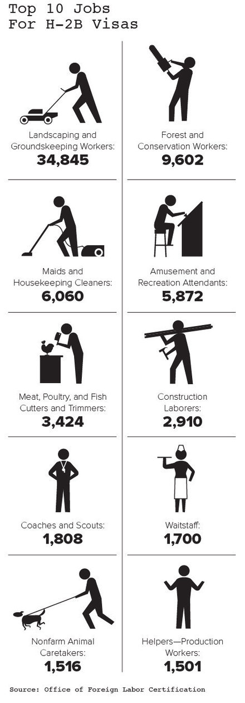
Standing on his expansive lawn beside a riding mower, West, who co-owns the crawfish producer L.T. West with his brother, said he treats his workers well. “My wife got holy water for them,” he said, adding that when they were not working he and his wife, Cathy, drove workers to Walmart or church, and sometimes invited them to relax in the shade of a tree that protects his house from the sun. But seven of his workers, including Valdez and Gonzalez, claim West took a different kind of interest in some of them. Some of their allegations include that he took to bursting into their trailer unexpectedly, even when they were dressing, and called them his “property” and his “Mexican ladies,” according to their complaint. Some of the women recall him saying things such as “mucho booby” and “mexicanas mucho booby,” gesturing for them to lift up their shirts. He instructed one of his other workers to tell the women in Spanish that the only way they could get out of poverty was to accept his propositions, which included requests that they come to his house when his wife was away. In the suit, the women did not allege he actually had sex with them. West, with his wife looking on, flatly denied the allegations, saying the women had made them up.
Cut off from their families, often unable to speak English, and beholden to their employers, women with H-2 visas are among the most vulnerable workers in America. Advocates and law enforcement officials say they have logged numerous reports of guest workers being coerced into having sex with their employers or being sexually harassed. Over and over, that abuse involves the threat of deportation — and the loss of desperately needed income.
Under such threats, workers describe attempts to control deeply private aspects of their lives, even their religious identity. When they worked at Harvest Time Seafood in Abbeville, Louisiana, Manuela Ruiz and her sister Yadira said workers were compelled to attend an evangelical church with their boss, Kevin Dartez, and his wife. Those who didn’t — even those who said they were Roman Catholic — were threatened with fewer hours, the sisters claimed in interviews. Employees were also ordered to keep their heads down while working, they said, and were forbidden to make eye contact with anyone of the opposite gender.
“We couldn’t talk to any men because we were told it’s disrespectful to their religion,” said Manuela, who worked at Harvest Time from 2007 to 2009 and is now back home in Sinaloa, Mexico. “A lot of workers got baptized in their church to ensure they got a visa for the following year,” she added. “It’s ugly to work like that.”
They said they never complained to outside authorities about being coerced to change their faith, or about their bosses confiscating their passports, or even about the seeping lesions that formed on their arms and legs that they attributed to chemicals in the crab bath. What finally convinced the sisters to seek outside help was Harvest Time cutting back on the one thing that made the pain and humiliation bearable: their wages. Dartez instructed his foremen to squeeze crabmeat after it had been pulled from shells, Ruiz said, making the juice run out and the meat weigh less. For workers paid by the pound, this meant less money. Particularly galling, she said, was that when the crab was canned, the juice was poured back in. A Labor Department investigation opened in 2011 found that Harvest Time owed workers more than $52,000 in back wages for 167 violations of worker protection laws. Dartez said he invited workers to his church but didn’t coerce them to follow his religious practice. “We weren’t choosing family or church or nothing,” he said in an interview. He did not confiscate passports, he said, though “the problem with giving them their passports, they can skip out anytime they want.” As for crab squeezing, he said it was the only way to stop his workers from adding water to bloat their pay: “They didn’t tell you that they patted their hand in the water bowl and dropped the water on the meat, did they?”
In an attempt to help workers who fall victim to abuses, U.S. consular officials hand out pamphlets to guest workers following their visa interviews. Among other information, that literature includes toll-free phone numbers they can call for help. Belinda Flores Shinshillas, an employee of the Mexican Consulate in New Orleans whose job was to protect Mexicans in the U.S., was on duty when a distress call came in from a worker at L.T. West. Flores and a colleague made the four-hour drive to the compound that very day. Recalling her first glimpse of the trailer where Valdez, Gonzalez, and other women stayed, she shook her head. “They didn’t have means to buy food. They didn’t have water to drink,” she said. “Based on the standards of today, those girls were slaves.” The women, Flores recalled, began to sob. “They didn’t believe someone was there to help them,” she said.
The Mexican government called a team of lawyers from Chicago, who came to Mamou and met with the women, taking statements and gathering evidence late at night to avoid detection. About a week later, the Mexican consul removed four women from L.T. West, including Valdez and Gonzalez, in another late-night operation. (Gonzalez couldn’t be reached for comment.) Others escaped separately and called a human trafficking hotline. The women together filed suit against L.T. West and the Mamou Police Department in federal district court in Lafayette. Mexico has repeatedly appealed to the U.S. to do more to protect guest workers. In 2003, 2005, and again in 2011, advocates petitioned the Mexican government to intervene on workers’ behalf under the North American Free Trade Agreement. Mexico’s Secretariat of Labor and Social Welfare forwarded the complaints to the U.S. Department of Labor but received little or no response. Mexico resubmitted the complaints in 2012, making clear that it considers mistreatment of H-2 workers to be a grave human rights abuse. “The 13th Amendment of the Constitution prohibits all forms of slavery or involuntary servitude, regardless of nationality, and therefore it protects H-2A and H-2B workers,” the Mexican government wrote.
It is the job of the U.S. government, the report continued, “to make sure workers are not intimidated, threatened or held against their will.” In response, the Labor Department said, it has taken steps to educate employers of their responsibilities and workers of their rights. Late in 2014 and early this year, it held a series of outreach events for guest workers in 15 states. At some of those events, a spokeswoman said, officials learned of 16 cases that may merit further investigation.
If a United States citizen were threatened on the job by a supervisor holding a gun or cornered by her boss while she was getting dressed, she might well go to the police. But H-2 visa holders rarely choose that option. “These are people that work 10 to 14 hours a day,” said Doug Molloy, a former assistant U.S. attorney in Florida who now works as a criminal defense attorney in Fort Myers, Florida. “People that wouldn’t know how to even call the police for help.” But another factor may also be at work: the close relationship that their employers have with local authorities. Even before Star One Staffing, a Miami labor staffing company, brought Filipino workers to the U.S. to clean hotel rooms, its owners informed those workers that the company had tight connections with politicians and police.
The company squeezed numerous unpermitted fees from its workers, at times reducing their net pay to less than $1 per hour, employees alleged. They also feared being deported, especially because the company was connected to “powerful people” such as Florida criminal judge Andrew Hague, who is married to the company’s president and who met the workers in the Philippines. In addition, workers said a police officer frequently visited the house where they slept, and they were brought to meet to a staffer for a U.S. congressman. Reached by phone, Judge Hague said he could not comment on the matter, and his wife, Mary Jane Hague, did not respond to requests seeking comment.
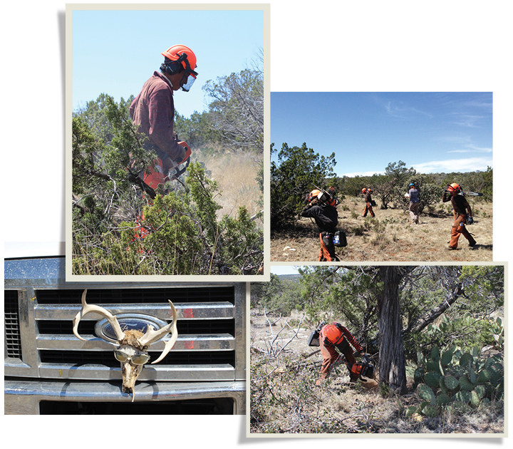
If workers ever tried to complain or leave, Star One managers “would have our visas revoked or deport us and we could never work in the U.S. again,” Robert Bautista, who shared a house with 40 other workers, said in a sworn declaration. “They were very powerful people and we all knew this.” In Mamou, West told his workers he was friends with local police and made a point of inviting an officer into the trailer where they lived, according to the lawsuit. When the Manuel brothers picked up Valdez and Gonzalez for their date, West called 911. “I asked [Sgt. McGee] why he brought the girls” to the station, Officer Brent Zackery said in a sworn deposition, “and he told me that Mr. West wanted him to scare them because they shouldn’t go out late like they did.” It worked, especially when, Zackery testified, Sgt. McGee threatened that they could be deported and pulled out the Taser. “That really scared the mess out of them,” Zackery said. Zackery also testified that, after the women filed their lawsuit, some of the officers conspired to cover up the Taser incident: If discharge tests were ever administered, they agreed that they would swap out McGee’s Taser with another one. Then they all went to Hooters for lunch. McGee is now Mamou’s police chief. He did not return calls seeking comment.
Ten months after the women were detained, the Labor Department’s Wage and Hour Division opened an investigation of L.T. West. The probe, begun in March 2012, was supposed to audit the treatment and pay of H-2 employees at the plant dating back almost two years. Although case files show the department was aware of the women’s lawsuit, the investigator waited until June to visit the plant — by which time crawfish season had ended, and almost all the workers had returned home. The inspector did not visit any worker housing at the crawfish plant. As for Craig West, he told the investigator that he had not kept complete payroll records — not even a daily log of hours worked — and didn’t have home addresses for his employees. In the end, the Department of Labor fined L.T. West $7,200 — not for underpaying or abusing its employees, but for keeping poor records.
BuzzFeed News reviewed more than three dozen investigations by the Department of Labor, the arm of the government that is supposed to ensure employers treat guest workers in accordance with the law. In most cases, inspectors interviewed few if any workers, showed up at workplaces only with advance warning, and accepted at face value the employer’s version of events. The Labor Department’s Wage and Hour Division investigated the Arkansas-based Superior Forestry — the largest forestry contractor in the country, according to the department — at least 15 times between 2000 and 2014. Few of those probes involved any worker interviews, records show. In one case, the inspector had not even been fully trained in applicable H-2 law. In a 2011 probe, investigators did interview workers, but only after setting up a formal visit far in advance with a third-party labor broker that handles Superior’s visa applications. The labor broker arranged for the interview to be conducted at a nearby motel rather than the job site, which inspectors did not visit. Still, they concluded that everything was in order, adding that the labor broker “makes sure all applicable laws are ‘followed to a T.’” None of the investigation reports mentioned that Superior had been sued in 2006 in Tennessee federal court by 2,200 H-2 workers who alleged the company did not pay them the promised wage or overtime; or that those workers were subsequently threatened by Superior agents who said they would report the workers to immigration if they didn’t drop the lawsuit; or that even after the court issued a protective order, a Superior recruiter spooked workers back home in Oaxaca, Mexico, by attending a meeting where legal information was being shared. “I can’t honestly say we do everything right all the time, but we try to,” said John Foley, an operations manager at the company, which has 25 full-time employees but brings in as many as 450 H-2 workers every year. “The laws are very confusing,” he added in a phone interview. “It’s telling that we have a full-time attorney.” The guest workers eventually won a $2.75 million settlement to resolve claims that they’d had millions in back wages stolen over a period of six years. But over the course of the Labor Department’s 15 investigations, the agency pinned only minor violations on the company, ordering Superior to repay its workers a total of just $12,652 in back wages over a dozen years.
For many companies, the financial incentive to underpay guest workers far outweighs the risk of getting caught, said Jacob Horwitz, an organizer for the National Guestworker Alliance in New Orleans. Stealing wages “is standard business practice,” he said. The Labor Department, in its statement, noted it has “finite resources” and “must be strategic” in how it deploys them for enforcement. It has sought greater powers to raise wages, prevent unlawful fees and retaliation against workers who speak out, and punish companies that break the law. However, it said, “these efforts have met with legal challenges and Congressional opposition.” In the case of the most egregious violations, the Department of Labor has the option of debarring a company — banning it for up to three years from bringing in guest workers. The department maintains a public list of companies under such censure; the current list has 76 names on it. Employers that do work for the federal government can also be debarred from future contracts.
That’s how it works in theory. This March, however, the Government Accountability Office found that the Department of Labor’s Wage and Hour Division failed to conclude more than half its investigations of H-2 employers within the two-year statute of limitations. And many companies that were repeatedly found to abuse workers were nevertheless granted more H-2 visas, lucrative federal contracts, and farm subsidies. Over the previous five years, government investigations found at least 12 firms underpaid H-2 workers by more than $100,000. Yet only one of them was debarred. Five — including an onion producer that had more than 1,400 violations and owed its Mexican workers $2.3 million in back wages — have been certified for more than 2,000 additional visas this year alone. In short, even though the U.S. government determined that these companies stiffed guest workers on a grand scale, it granted them the right to bring in more.
Some companies the Labor Department moves to debar nonetheless continue to receive government contracts. Garcia Forest Service was caught multiple times stealing thousands of dollars in wages from guest workers, misleading investigators, and doctoring time sheets to cover it up. “Some of these violations were innocent mistakes,” Garcia’s attorney, Ray Perez, said in an interview. “A lot of the times the investigators have it in their mind that they’re going to nitpick you and get you.” The Labor Department didn’t see it that way and debarred the company from receiving federal contracts for three years starting in March of last year. But so far, the ban has had little if any effect. The Rockingham, North Carolina, company appealed, and while awaiting a final ruling it has been awarded $715,082 in contracts from the U.S. Forest Service, including a $72,147 award early this month to spray herbicide on 529 acres of the Apalachicola National Forest in Florida.
During her four years auditing companies with H-2 visas, said Kalen Fraser, the former Wage and Hour Division investigator, she saw terrible abuses. She recalled the agricultural guest workers in western Colorado who slept four to a room in a filthy old roadside motel, cooking on hot plates on the floor and unable to drink the tap water because the plumbing was defective and actually issued electric shocks. “That was really an instance of you feeling horrible because people are just living in really bad conditions,” said Fraser, who now helps employers comply with labor laws. She fined their employer, but did not escalate the case or refer it to law enforcement. Indeed, Fraser said, despite seeing hundreds of serious violations, she never recommended a single case to the FBI, Immigration and Customs Enforcement, or her own inspector general, all of which can bring criminal actions. “We didn’t do any criminal stuff,” she said. “If you see a problem, you don’t stomp out and say something.” Instead, she said, she and other Labor Department inspectors would ask companies “to agree not to hold people’s passports, not to deduct wages, etc. And hopefully they agree to that.”
In January 2013, Valdez, Gonzalez, and the other women reached a final settlement in their lawsuit with L.T. West and the city of Mamou. The city paid Valdez and Gonzalez $20,000 each. L.T. West settled with all seven plaintiffs, but the amount is confidential. Today, Valdez doesn’t want to say where she is living. She declined to discuss the allegations in the lawsuit, or the settlement. She signed a confidentiality agreement. But looking back, she said that a big part of being a guest worker is feeling “vulnerable” and “like we’re not worth anything.” “We make lots of plans; we think this is the thing that is going to change our lives for the better. We have so many illusions about what it’s going to be like,” she said. And then when it’s not, “you get desperate. You feel like there won’t be any more opportunities. You so badly want to go home but not like this, not like a failure. It’s not just your dreams and your illusions. It’s your mom and dad, your kids: ‘Oh my mom is going to bring me this thing,’” but then “having to come back with empty hands.” She continued: “People have asked me whether they should go to the U.S.” on an H-2 visa. “They say they want to go and ask if I can help. But, honestly,” she said, “I just tell them I don’t know anyone who can help.”

Source: http://www.buzzfeed.com/jessicagarrison/the-new-american-slavery-invited-to-the-us-foreign-workers-f#.esgplrWJ8

