CWA Class Notes
February 10, 2016 Unit: Global Issues – Commodity
EQ: How is the reality of modern day slavery related to the concept of a “commodity?”
Watch the video: Commodities
-What are commodities?
-What determines the value of a commodity?
-What happens to commodities over time?
Complete the “Four Corners Graphic on the word “commodity” | 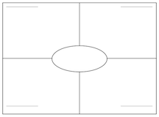
What are three commodities that you buy / use every day? | -  -  -
Complete the diagram on how a commodity flows to the final user:
Summarize by answering the above EQs in paragraph form:

