CWA: Identifying the Symptoms vs. Causes of Problems
EQ: What are the effects (visual signs) and real causes of “modern day slavery?”

On the “Tree diagram”  List as many symptoms (effects) of having the flu in the “branches” section  List as many reasons (causes of) for getting the flu in the “root” section | 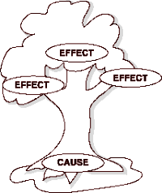  Flu
Now create another tree diagram for modern day slavery that summarizes all you know about it… | Modern Slavery
Summarize by answering EQ in ¶ form

