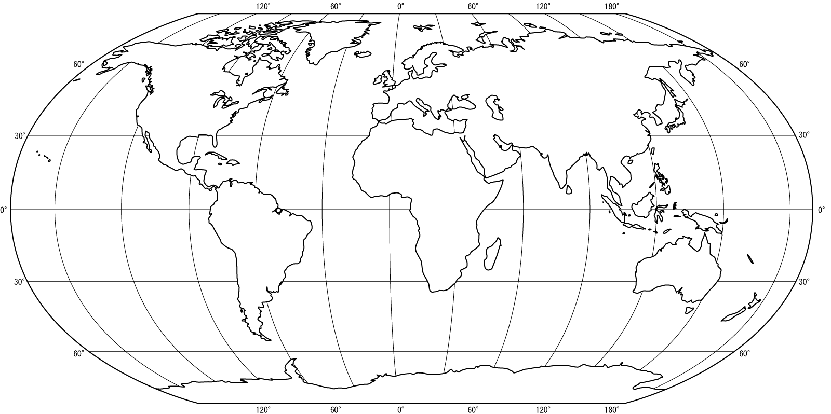
Contemporary World Affairs: World Geography Basics Map 1

