Afghanistan: Kite Runner Case Study Pre-Activity – Historical Overview of Afghanistan

THIS IS A CLASS SET OF DOCUMENTARY EVIDENCE. DO NOT WRITE ON THE DOCUMENTS. IF YOU DESIRE TO TAKE NOTES, DO SO ON YOUR OWN PAPER OR DEVICE

Read and analyze the text and other informational documents provided on the history of Afghanistan, then discuss the following questions as instructed. Once you have gained understanding of Afghanistan’s historical background, write short paragraph answers based on your personal understanding and opinions.
Discussion Questions: Based on the evidence in the documents…
- What patterns of external influence do you notice upon Afghanistan?
- Which nations or organizations have tried to influence Afghanistan? How so and why?
- In what ways has Afghanistan been affected by external influences?
- Sometimes existing governments are unable to sufficiently protect its national borders from external influences. Whose responsibility is it to protect nations like Afghanistan when they become the targets of stronger nations?

Document 1
Afghanistan is a country that has a history of being politically unstable. There are several “states within a state” and the lack of a strong central government has given rise to regionalism, warlordism and religious fundamentalism. There have also been numerous external factors and actions that have led to the country’s current state, such as the Russian invasion of 1980. For the last few centuries at least, Afghanistan has been a buffer zone as well as a zone of contention for a variety of foreign influencers.

Source: Amnesty International
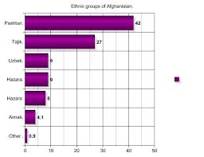
Document 2
Ethnicity in Afghanistan

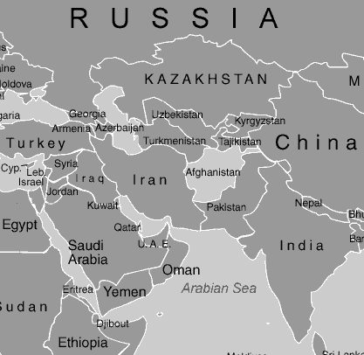
Document 3
Southwest Asia Regional Map

Source: www.socsci.gulfcoast.edu
Document 4
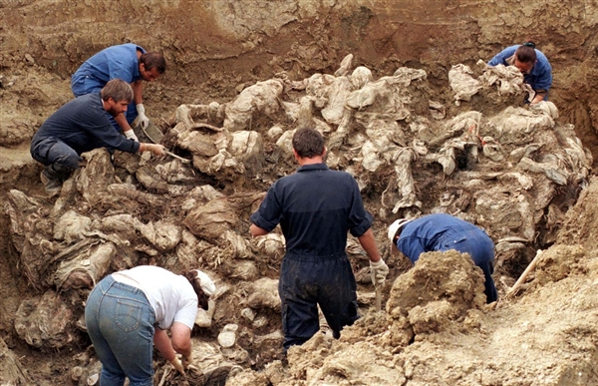
As of July 2007, the United Nations has invited forensic specialists from an international organization to help investigate over 80 mass graves discovered in different parts of war-torn Afghanistan. According to the Afghan Independent Human Rights Commission, these grave are sites where thousands of human beings have been buried… It is thought that most of these graves are from the Soviet era; however, some are from the Taliban era

Source: Amnesty International & nbcnews.com

