Human Geography: Chapter 1.8 Global Scale – Using ESPeN to analyze visual data
Source: https://www.thestreet.com/story/14260701/1/mcdonald-s-doubling-china-locations-by-2022.html
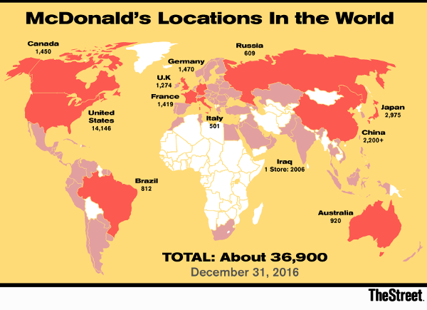

List 3-4 bullet notes in the boxes below to reflect relevant facts from the information source and / or your thoughts
Economic | Social [including Cultural aspects]
Political | eNvironmental [including site, location, situation]
Combine your bullet notes above to construct a concise, well-written paragraph [in full and complete sentences] that summarizes the impact of Mc Donald’s operating on a global scale. Use back if needed.

