AP Human Geography: Chapter 1 – Place Introduction Activity NAME:_________________________ DATE:_______
“Humans possess a strong sense of place – the features that contribute to the distinctiveness of a particular spot on the Earth… Geographers describe a feature’s place on earth by identifying its location, the position that something occupies on Earth’s surface… Because all inhabited places on Earth’s surface – and most uninhabited places –have been named, the most straightforward way to describe a particular location is often by referring to its place name, or… toponym… “
Toponym | Frequency Selected | Toponym | Frequency Selected
Alaska | 3 | New York | 10
Boston | 2 | New York City | 3
East Coast | 1 | Orlando | 1
Glendale (CA or AZ?) | 1 | Seattle | 1
Hawaii | 7 | Southern California Coast | 1
Maryland | 1 | Vail, CO | 1
Massachusetts | 1 | Washington DC | 1
New Orleans | 3
“Space… [is] the physical gap or interval between two objects… spatial thinking is the most fundamental skill that geographers possess to understand the arrangement of objects across Earth… On earth as a whole, or within an area of Earth, features may be numerous or scarce, close together or far apart. The arrangement of a feature in space is known as its distribution. Geographers identify three main properties of distribution – density, concentration and pattern… Density is the frequency [amount] with which something occurs in space [a given area]… Density involves two measure – the number of a feature and the land area… The extent of a feature’s spread over space is its concentration. If the objects in an area are close together they are clustered; if relatively far apart they are dispersed… Geographers use concentration to describe changes in density… the third property of distribution is pattern, which is the geometric arrangement of objects in space. Some features are organized in a geometric pattern, whereas others are distributed irregularly…”
-Source: The Cultural Landscape, 12th / AP ed. by James M. Rubenstein, 2017
1. Use the data gathered from the “Free Trip” scenario provided on the right to create a map:
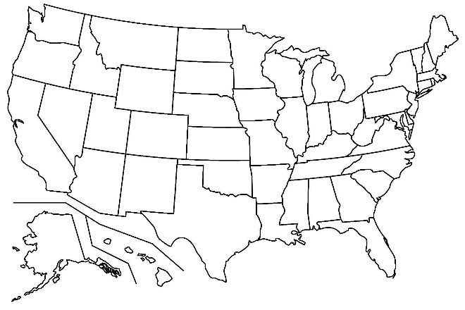

2. Describe the variety of ways the survey group chose to use the term “place”

3. Analyze the data and create a new toponym that defines the place areas the survey group chose.

4. Based on the information provided, explain which THREE areas you created above are the most dense.

5. Based on the information provided, explain whether the concentrations are clustered or dispersed. How might the concept of distance have played into the choices made?

6. Based on the information provided, explain the pattern of the choices made.

