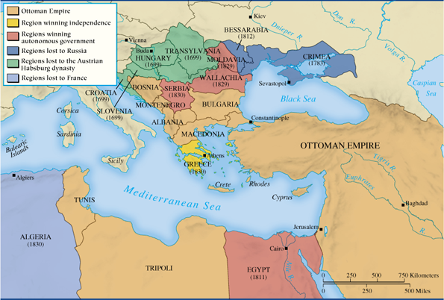
AP Euro: Chapter 22 Age of Nationalism & Realism – Map Activity and Spatial Reasoning – Declining Ottoman Empire

Q1. What is the relationship between the distance from Constantinople and the date that a region was lost to the Ottoman Empire? Explain.

Q2. How did 18th & 19th c. events in other parts of Europe impact the Ottoman Empire internally?

Q3. What outside pressures did the Ottoman Empire face from its European neighbors in the 19th c.? Why?

Q4. Why did the Crimea become a focal point & how did the Crimean War (1850s) impact its participants?

