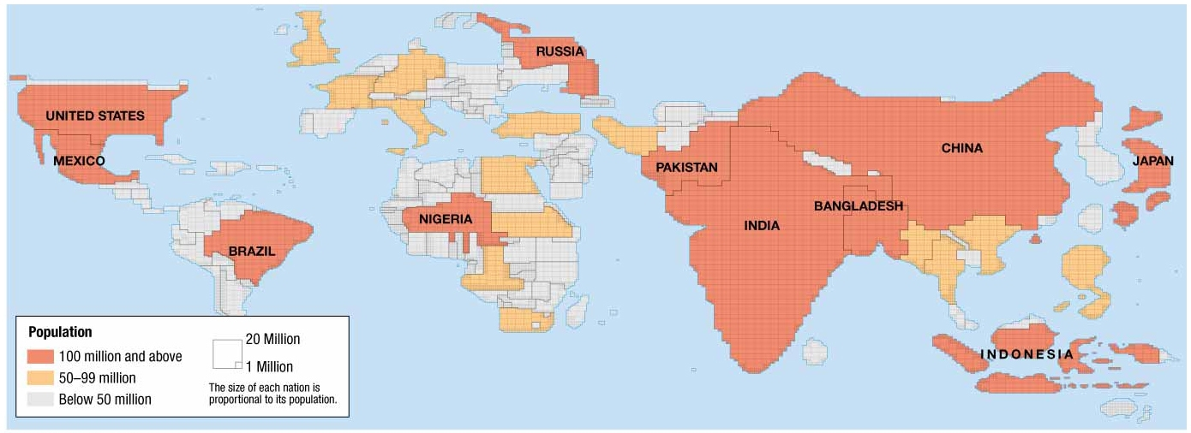
Human Geography: Chapter 2 Population & Health ESPeN – Cartograms (2.1)
Source: Contemporary Human Geography, 3rd ed. by James Rubenstein, p.36

List 2-3 bullet notes in the boxes below to reflect relevant facts from the information source and / or your thoughts
Economic | Social [including Cultural aspects]
Political | eNvironmental [including site, location, situation]
Combine your bullet notes above to construct a concise, well-written paragraph [in full and complete sentences] that summarizes the Economic / Social / Political /Environmental impacts based on the information in the cartogram above.

Human Geography: Chapter 2.2 – Population Density Terms, Calculations & Analysis
Vocabulary Term | Definition / How to Calculate | Where on Earth is it the highest?
Arithmetic Density

Physiological Density

Agricultural Density

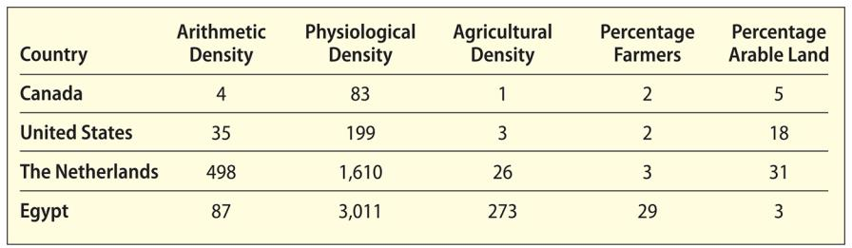
Use the data chart on the right to analyze the four countries ability to provide food for its people.
The unit of measurement used to calculate each density is square kilometers.
Q1: a. Which country in the chart is the most crowded?

b. Which calculation is used to determine that?

Q2. Which country has the most difficulty feeding its people? Explain which data proves that?

Q3. What might account for the large difference in population of Percentage Farmers between Egypt & the others?

