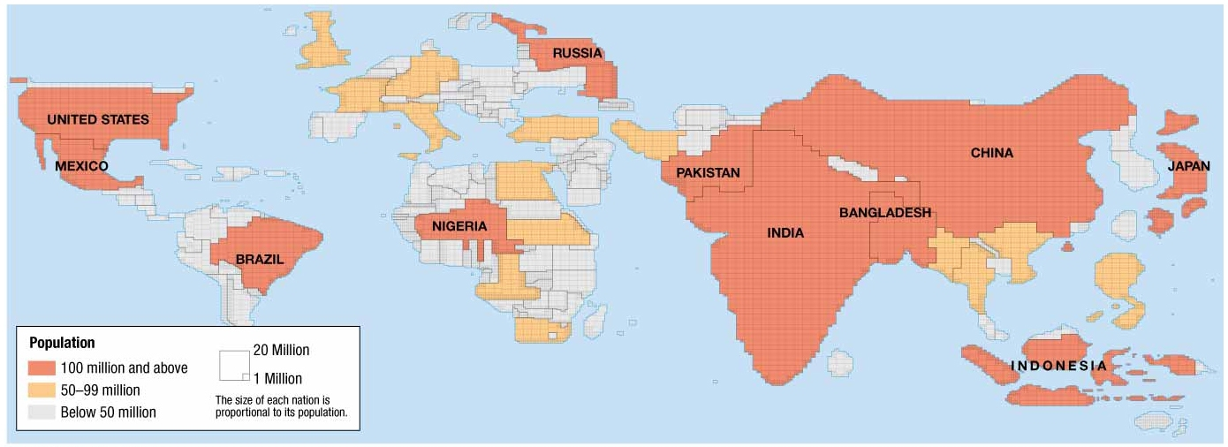
Human Geography: Chapter 2 Population & Health ESPeN - Cartograms
Source: The Cultural Landscape, 11th ed. by James Rubenstein, p.45

List 3-4 bullet notes in the boxes below to reflect relevant facts from the information source and / or your thoughts
Economic | Social [including Cultural aspects]
Political | eNvironmental [including site, location, situation]
Combine your bullet notes above to construct a concise, well-written paragraph [in full and complete sentences] that summarizes the greater and deeper scope of the original source information.

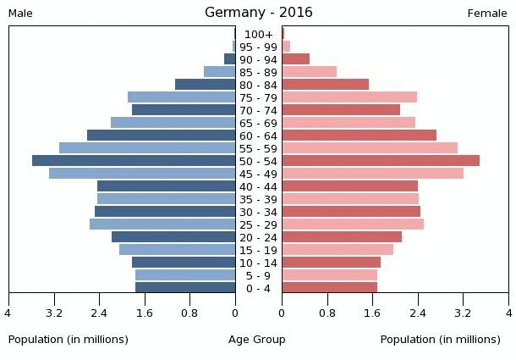
Human Geography: Chapter 2: Population & Health – Germany Population Pyramid
Source: https://www.indexmundi.com/germany/age_structure.html
List 3-4 bullet notes in the boxes below to reflect relevant facts from the information source and / or your thoughts
Economic | Social [including Age & Gender aspects]
Political | eNvironmental [including site, location, situation]
Combine your bullet notes above to construct a concise, well-written paragraph [in full and complete sentences] that summarizes the greater and deeper scope of the original source information.

