Human Geography: Chapter 2 Exam Study Guide
- Key Definitions to KNOW
Vocabulary Term | Answer | Definition Options
1. Crude Death Rate (CDR) |  | a. The average number of years an infant can expect to live
2. Total Fertility Rate (TFR) |  | b. The amount of people in a given area of space
3. Infant Mortality Rate (IMR) |  | c. The total number of live births per 1000 people in a year
4. Physiological Density |  | d. The number of farmers per unit of arable land
5. Dependency Ratio |  | e. The average number of children a woman will birth during her childbearing years
6. Agricultural Density |  | f. The percent a population grows in a year, excluding migration
7. Natural Increase Rate (NIR) |  | g. The number of people supported per unit of arable land
8. Arithmetic Density |  | h. The number of people under 14 & over 65 compared to those of working age
9. Crude Birth Rate (CBR) |  | i. The total number of deaths per 1000 people in a year
10. Life Expectancy |  | j. The number of babies 1 year old and under who die in a year

- Key Statistics to BE ABLE to CALCULATE
Vocabulary Term | Answer
11. Natural Increase Rate (NIR) |  | k. 70 / NIR = ?
12. Dependency Ratio (DEPR) |  | l. (CBR – CDR) / 10 = ? %
13. Doubling Time (DT) |  | m. (# 14 and under + # over 65) / # Working Age Population

- Statistics Calculation Practice
Country | CBR | CDR | % under 14 | % over 65 | % Working Age | NIR | DT | DEP | DTM Stage?
A | 30 | 5 | 40 | 5 | 55
B | 18 | 6 | 28 | 7 | 65
C | 12 | 9 | 25 | 15 | 60
D | 7 | 10 | 10 | 55 | 35

- Demographic Transition model (DTM) Stages Analysis
DTM Stage | CBR Level  Describe | CDR Level  Describe | NIR Trend  Describe | Pop Pyramid Shape | Health Indicators: Disease Types | Global Location
2
3
4
5

- Other Population Considerations to KNOW:
Questions from textbook & source material | Answer in short sentences or phrases
15. According to Thomas Malthus, what would cause a population crisis?
16. According to Dr. Hans Rosling,  a. what is the approximate global population today?  b. what will be the maximum global population?  c. what are the FOUR reasons we need not panic about overpopulation?  d. what is happening in Third World countries like Bangladesh regarding population control? | a.  b.  c.  d.
17. What are the different ways places like China, India & Bangladesh have tried to control overpopulation? | China =  India =  Bangladesh =
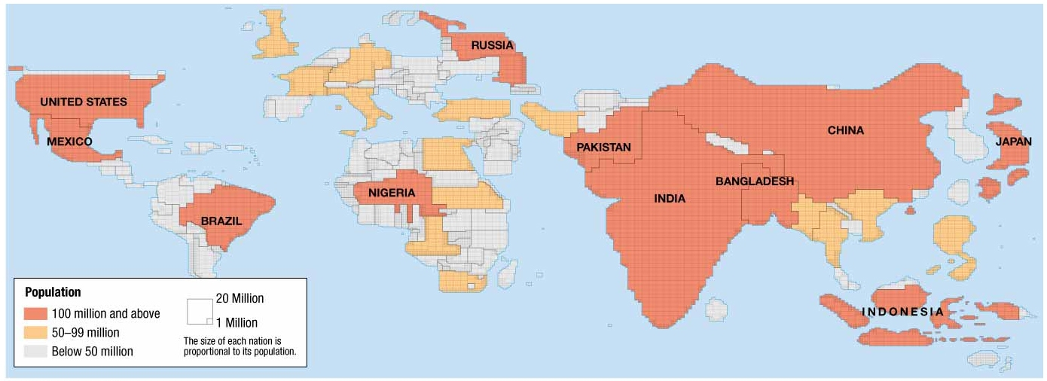
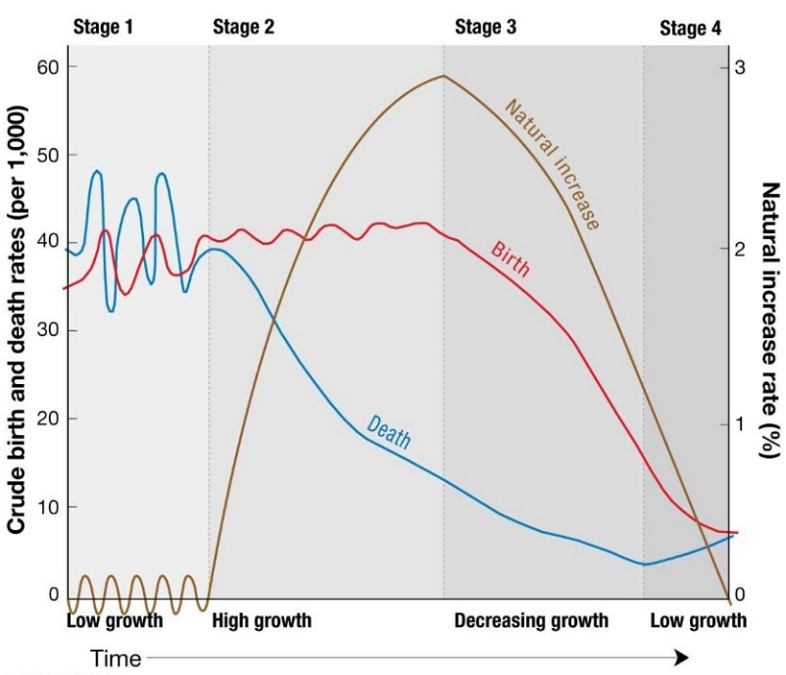
- Visuals to be Able to Interpret:
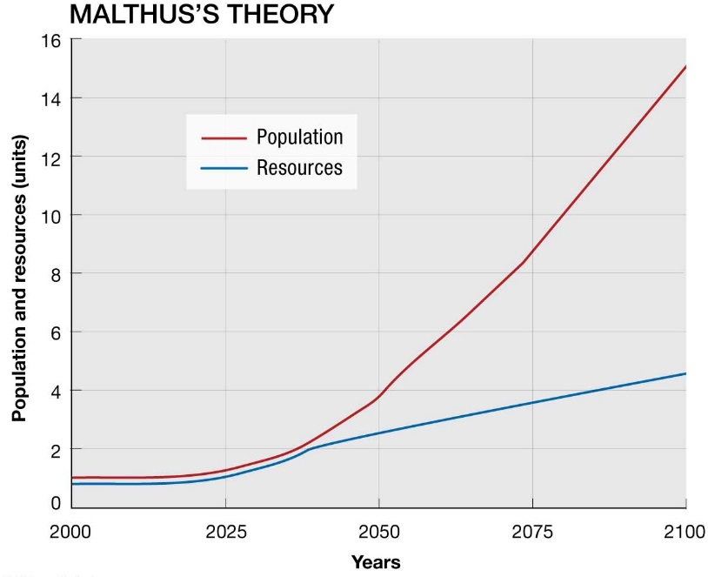
The Cartogram, what is its meaning? >
Demographic Transition Model below: ID what is happening in each stage. What type of countries represent each stage? What does the population pyramid of each stage look like?
Why is this area a point of crisis?

