HUG: Chapter 2 Review – Population Concentration (2.1), Density (2.2), Growth (2.3) & Demographic Transition (2.4)
Part I: Answer the review questions below:
- Based on current data, the human population of the Earth is about

  - 3 billion
  - 5 billion
  - 7 billion
  - 11 billion

- The most populated region of the Earth is currently

  - Africa
  - The Americas
  - Asia
  - Europe

Part II: Use the information below to complete the chart provided
- Arithmetic Density = Population / Land Area
- Crude Birth Rate % (CBR) = # Births / 1000 People [does not include any migration]
- Crude Death Rate % (CDR) = # Deaths / 1000 people [does not include any migration]
- Natural Increase Rate % (NIR) = (CBR – CDR) / 10
- Population Doubling Time (DT) = 70 / NIR (as a whole #, not %)

 | Population  (millions) | Land Area  (Sq. Mi.) | Arithmetic Density  (pop/Sq. Mi) | Crude Birth Rate  CBR  (per 1000) | Crude Death rate  CDR  (per 1000) | Natural Increase Rate  NIR (%) | Doubling Time (DT)  (in years)
Country A | 50 mil | 600,000 |  | 30 | 6
Country B | 180 mil | 60,000 |  | 20 | 5
Country C | 50 mil | 2,500,000 |  | 10 | 8

Continue to other side for Part III >>>

Part III. List TWO to THREE (2-3) key facts about EACH stage of the Demographic transition Model in the boxes below
Stage 4:
-
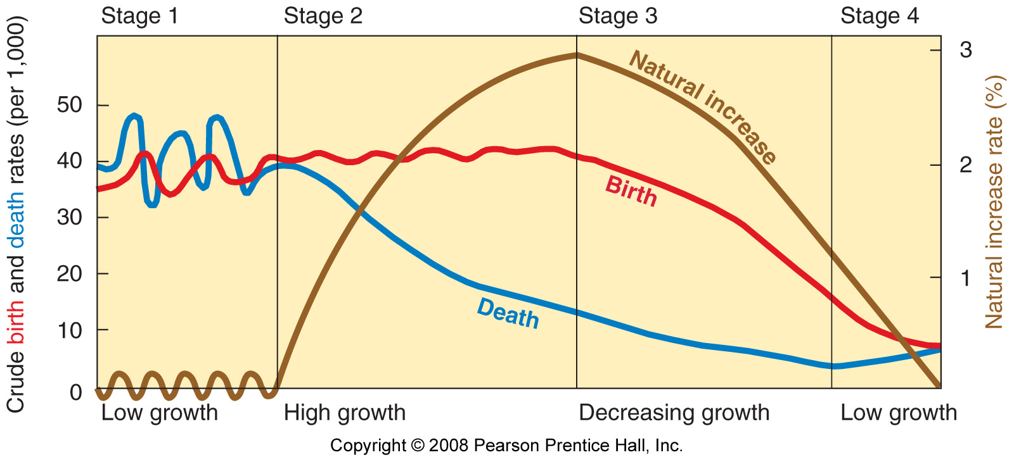
Stage 3:
-

-

-
Stage 2:
-

-

-
Stage 1:
-

-

Summarize the Demographic Transition Model Stages in 5-7 sentences:

