Human Geography: China & Children – Upfront Magazine 09/19/2016 by Brooke Ross
Read, annotate the key information & any observations (AHA! Moments). Answer the Qs at the end. Discuss!
China’s Left-Behind Children: A booming economy is tearing millions of workers away from their families. What can be done to help a generation of kids growing up without their parents?

Deep in rural western China, Yuwen Tang, 12, shares a one-room shack with his grandmother, younger brother, and two cousins. There isn’t much privacy; they bathe in a metal tub on the floor and share a toilet with neighbors. Yuwen is constantly surrounded by people—except for the two he misses most: his mom and dad.
Yuwen’s parents live in the city of Chengdu, several hours away from Yuwen’s home in Sichuan province. There, they work in a textile factory, churning out the kinds of products that have helped transform China’s economy into the second largest in the world (after the U.S.). Still, they’re barely scraping by, and Yuwen sees them only two or three times a year. “I know it is hard for Mom and Dad to earn money,” he recently told the BBC. “But I miss them so much. It’s very painful.”
In Guizhou province, Gu Guangfeng has been taking care of her 15-year-old grandson and his younger sister for more than a decade. Gu’s son left his home village in search of work when the boy was just 2 years old, and has never returned. Their mother has since remarried. “We can only tell the children the truth, that their parents have left,” Gu recently told The Statesman, an Indian newspaper.
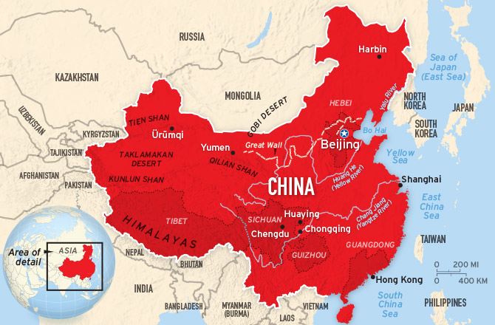
These children are part of what’s known as China’s “left-behind generation.” They live in rural areas while one or more of their parents live and work in China’s cities—often the only place to find jobs. According to rough estimates, there are about 61 million left-behind children in China—one-fifth of all kids in the country.
Map: Jim Mcmahon/Mapman®
From the Villages to the Cities: Although children face serious risks growing up without their parents, including abuse and depression, many Chinese feel they have no choice but to leave their kids behind. Why? Doing so allows their children to stay in school. While rural migrants are free to work in China’s flourishing cities, they and their families aren’t allowed to access government services there. That includes public schools and health care. “Left-behind children are one of China’s best-kept secrets,” says Kam Wing Chan, a geography professor at the University of Washington and an expert on Chinese migration. “It’s a very big issue that needs to be better known.”
Recently, advocates for left-behind children have begun working to bring attention to the issue, prompting calls for China to end the policies that keep migrant families apart. How the government decides to act could have a huge impact—not just on the millions of left-behind kids, but also on the Chinese economy that this generation will one day have to sustain.
About half of China’s left-behind children live with one parent while the other is away working. Another 44 percent are like Yuwen: left in the care of family members, usually grandparents, so both parents can work. And 3 percent—that’s 2 million kids—live by themselves with no relatives to rely on at all. The phenomenon of left-behind children is a by-product of the largest human migration in history. In recent decades, about 270 million Chinese have left their villages in the mostly rural provinces of Sichuan, Guizhou, and other remote areas to take jobs in China’s cities.

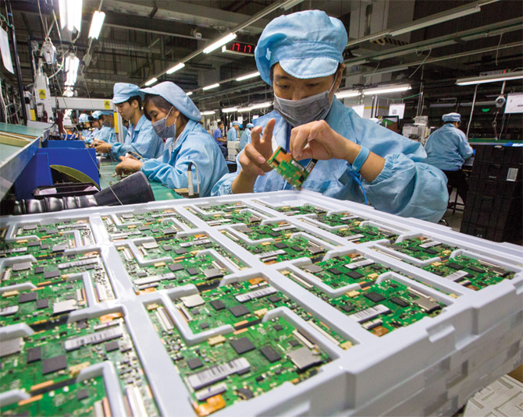
Photo: Ng Han Guan/AP Images: Workers at an electronics factory in Guangdong Province
Once poor and isolated under a repressive government, China has transformed itself into an economic giant in recent decades. In 1978, the Communist nation’s leaders adopted reforms that loosened governmental control of the economy. Thanks to these changes, other nations rushed to do business with China. Technology firms and clothing manufacturers took advantage of the nation’s skilled, low-paid workforce, and today China makes everything from jeans to iPhones.
Many migrants jump at the chance to work 12-hour days in China’s factories manufacturing such products. The pay is low, but it’s still more than they’d earn in their villages, which are often crippled by poverty. Most parents, including Yuwen’s, send money home to their kids as often as they can. “I’m so worried because I’m not with him,” Yuwen’s mother tearfully told reporters. “If there were no legal barriers, we would bring him with us.”
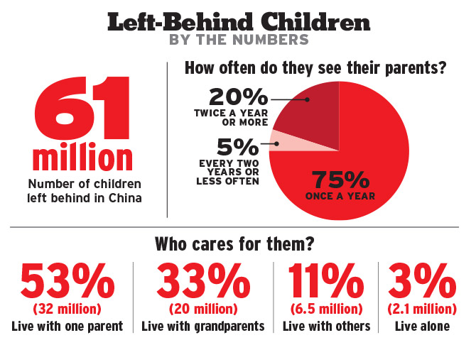
Abuse, Violence & Injury: Unlike in the U.S.—where a family in rural Wyoming, for example, is free to move to any American city—China operates under a rigid household registration policy. It’s called the hukou (who-kow) system. Established in 1958 under Communist ruler Mao Zedong, the system classifies all citizens as either rural or urban. It says that residents may work anywhere they choose—but can receive government-funded services only in the place where they were born. The hukou system was created to keep rural families from flooding into cities. It was designed to prevent the development of urban slums—a huge concern for Chinese officials—but it also allows the governments of Beijing, Shanghai, and other large cities to avoid paying for services for migrants and their children.
The policy successfully prevented urban migration for many years, but as China’s economy grew, suddenly, millions of rural Chinese began moving to cities anyway in search of jobs. Willing to give up their own health care—but not their children’s health care or schooling—desperate parents leave their sons and daughters in the best living situation they can. It’s often a gut-wrenching decision, with the children left to bear the ultimate burden.
Left-behind children are at increased risk for abuse, violence, and injury, according to a recent UNICEF report. In 2015, four siblings living by themselves in rural southwest China died of pesticide poisoning. Left-behind children also suffer emotionally. About 25 percent say they have no hope for their future, according to Lijun Chen, a researcher at the University of Chicago Center in Beijing. He is the co-author of a recent study on the mental health of left-behind children.
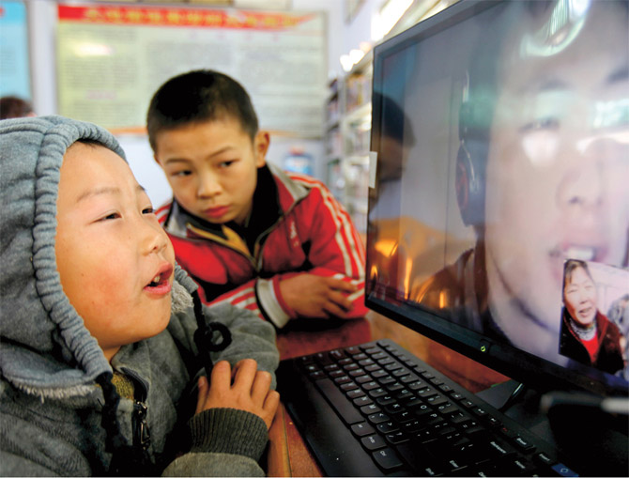
Ironically, while most migrant parents cite education as the primary reason they leave their kids behind, their children often do poorly in school. Rural teachers often report that their left-behind students have difficulty focusing on assignments. Many have a hard time getting to class since schools in China’s countryside are usually far from villagers’ homes. Only about 3 percent of rural students graduate from high school, compared with 63 percent of urban students. “If little is done to improve left-behind children’s circumstances soon, there will be enormous long-term costs,” warns Chen. “Many of them will not become productive citizens.”
Photo: Top Photo Corporation/REX/Shutterstock: Left-behind children in Huaying use a public computer to talk to their parents who are away working
Economic Fallout: But there’s more at stake than just the children’s welfare. The left-behind crisis could also spell disaster for China’s economy. Thanks to its history of population control, China already has a low proportion of children overall. In 1980, the country adopted a controversial policy limiting families to one child each. Although the one-child policy was abolished last year, today only about 17 percent of Chinese are under the age of 15 (compared with the worldwide average of 26 percent). At the same time, the number of Chinese over age 60 is increasing. This—along with the fact that migrants have been deterred from bringing their kids to the country’s urban areas—has many experts worried. In future decades there may not be enough young, educated workers in China’s cities to replace those who are retiring—and to produce the goods that drive the nation’s economy.
Fortunately, China is starting to take notice of its youngest, most vulnerable people. Officials recently announced that they’re conducting the country’s first census of left-behind children to determine their exact numbers and location. And earlier this year, China’s government issued a directive setting out guidelines for the care of left-behind children. The order calls on rural governments and schools to work together to look after young residents, while urging parents to ensure their children are in good hands if they must leave.
Local communities are also stepping up. Social workers are working with thousands of left-behind children, making sure they have the care they need. An expanding network of Chinese college students has also begun regularly visiting rural schools to mentor left-behind children and help them with homework. Such measures are a step in the right direction, yet many people are calling on the government to do more, starting with sweeping reforms to the hukou system. Changes to the policy have been in discussion for years, but officials have yet to act. “The hukou system is unfair and unsustainable,” says the University of Washington’s Chan. “Ultimately, China needs to reform or abolish the system if it’s to become a modern country.”
Study author Chen agrees. In his report, he calls for ending the policies that keep migrant parents away from their children. “Every child,” he says, “should be given an environment in which they can prosper.”
Q1: Why does the author claim that China is leaving some of its children “behind?” How has migration led to this?

Q2: How has adult internal migration impacted their children?

Q3: How is the Chinese government acting to resolve the problem generated by its policies?

