Human Geography: Chapter 3 Migration ESPeN – Global Migration Patterns
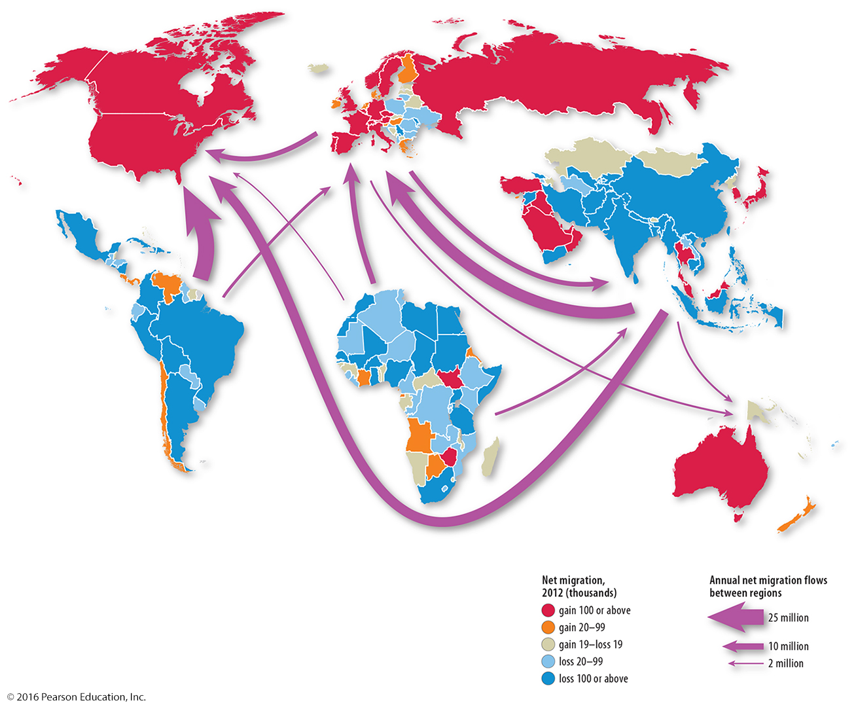
Source: Contemporary Human Geography, 3rd ed. by James Rubenstein, p.63, Figure 3.1.6

List 3-4 bullet notes in the boxes below to reflect relevant facts from the information source and / or your thoughts
Economic | Social [including Cultural aspects]
Political | eNvironmental [including site, location, situation]
Combine your bullet notes above to construct a concise, well-written paragraph [in full and complete sentences] that summarizes the your understanding of the original source information and how it impacts the world in multiple ways.

