Directions: Label the map of Los Angeles indicating the various ethnic enclaves that make up the city. For each ethnic enclave, shade it a specific color indicating where in Los Angeles it is located. Make sure to include a “key” that indicates which neighborhood is represented by which color.
Map Key:
Chinese | Filipinotown | Koreatown | Thai Town | Pico-R’son
Little Armenia | Olvera St | Little Tokyo | Little Ethiopia | Leimert Park

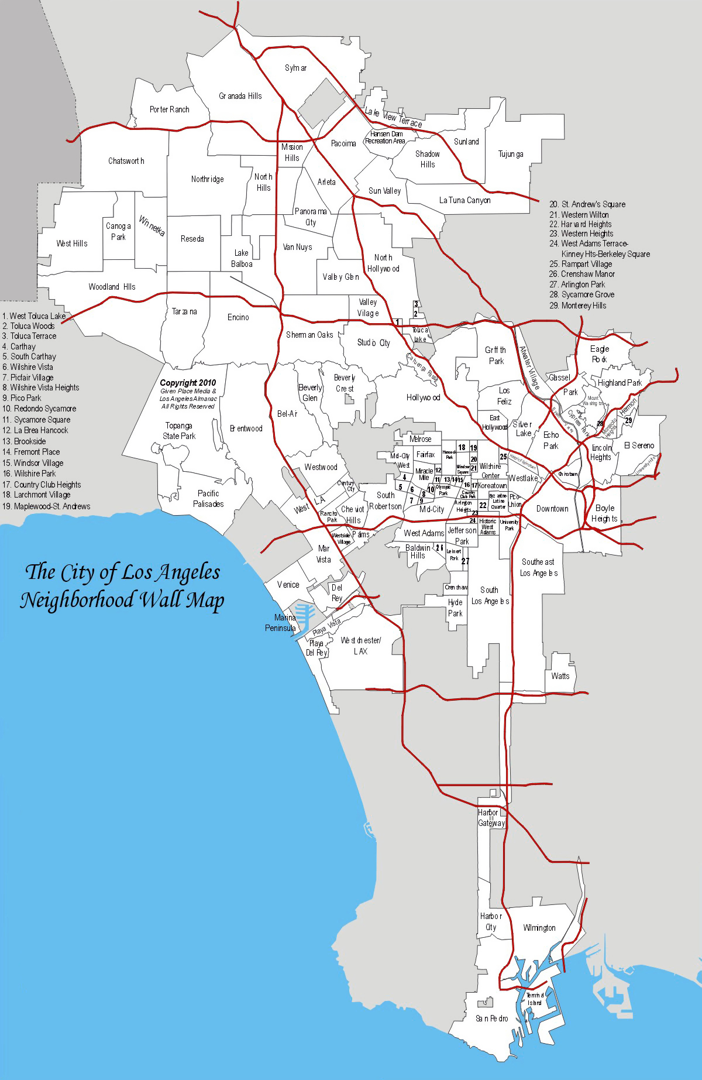

Human Geography Chapter 7: Ethnic Enclaves of Los Angeles
Directions: Fill out the chart below regarding 10 specific ethnic enclaves here in Los Angeles. These are the same 10 ethnic enclaves that you will be mapping for part 2 of the assignment.

Ethnic Enclave | Who | When was it founded? | What aspects of cultural can you find there?
Chinatown |  |  | *  *
Little Armenia |  |  | *  *
Historic Filipinotown |  |  | *  *
Olvera Street |  |  | *  *
Koreatown |  |  | *  *
Little Tokyo |  |  | *  *
Thai Town |  |  | *  *
Little Ethiopia |  |  | *  *
Pico-Robertson |  |  | *  *
Leimert Park |  |  | *  *

Useful Websites:
-https://theculturetrip.com/north-america/usa/california/articles/10-neighborhoods-celebrating-culture-in-la/
-https://www.sfgate.com/travel/article/The-many-culturally-rich-ethnic-neighborhoods-of-6062875.php
-https://www.frommers.com/destinations/los-angeles/attractions/ethnic-neighborhoods
-http://www.visatopia.com/resources-library/living-in-california/top-ten-ethnic-neighborhoods-in-la/

