Chapter 8: Key Issue 1

*Where Are States Distributed?*

1. List the five countries with the largest land areas:
2. What is meant by a microstate? (Define it and list a few examples)
3. The United Nations was formed after World War II ended in 1945. Membership has increased from the original 49 states in 1945 to 193 members in 2011. This growth occurred largely in three bursts. Identify the reasons why membership in the UNO exploded in the following years:

1955

1960

1990-1993

1. The League of Nations was the predecessor of the United Nations, and proved unable to stop the aggression of nations like Germany, Japan, and Italy prior to World War 2. Why did the League fail?
2. What are “UN peacekeeping forces”? What has been the obstacle to using these forces?
3. Describe some of the successes the peacekeeping forces have had.
4. Please make bulleted point notes about the question of **sovereignty** that the following countries raise.

|  |  |  |
| --- | --- | --- |
| North and South Korea | Taiwan and China | Sahrawi Republic (Western Sahara) |
|  |  |  |

1. Where did the first city-states and empires arise? What important rivers were they based on? Why?
2. Describe how the feudal system (political system that replaced the Western Roman Empire) worked in Medieval Europe (Middle Ages 500 - 1400 AD).

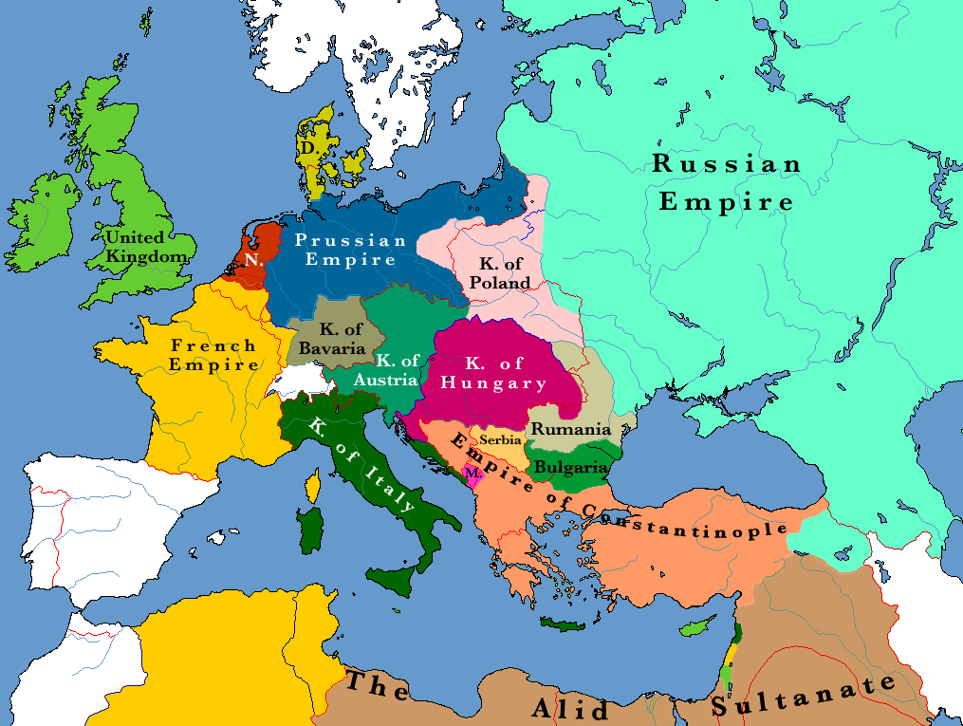

1. Use space provided below and the two adjacent maps (Europe in 1884 at near the height of European imperialism and Europe in 1924 in the aftermath of World War 1) explain how the concept of self-determination and ethnic identity would account for the geographic differences.

1884

