AP Human Geography: Chapter 8 Political Geography – Key Issue 3
African Nation Shapes
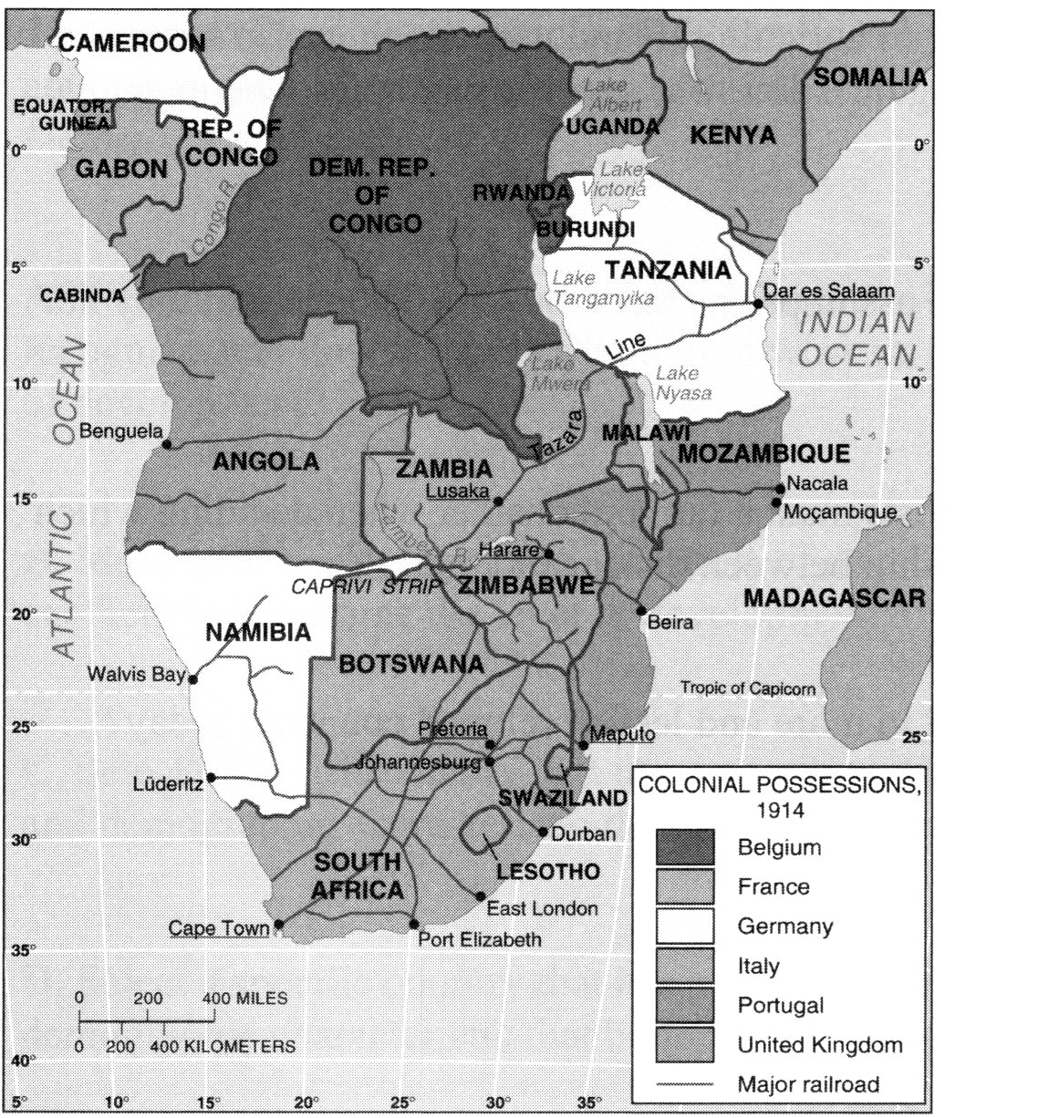
- The map below shows modern Southern Africa. Please identify an example on the map for each of the following types of country shapes:

Perforated:

Elongated:

Compact:

Fragmented:

Prorupted:

- Identify one example of a geometric border.

- Identify one example of a natural border.

- Identify one landlocked state.

- Why are the borders in Southern Africa so controversial?

