Chapter 8: Key Issue 2: Why are Nation-States Difficult to Create?

1. Complete the table below:

Type of State | Name of State(s) | Location | Reasons & Key Info
Nation-State
Multiethnic
Multinational

2. Complete the table below regarding the former Union of Soviet Socialist Republics (USSR) aka the Soviet Union
Region | Soviet Republic Name | Main / Second Language | Key Facts x2
Baltic States (3)
European States (3)
Central Asian States (5)
Caucasian States (3)
Eurasian State (1)

- Explain the main reasons why ethnic tensions continue to exist within the former Soviet republics.

- Explain the difference between colonialism and imperialism.

- Describe where the French and British colonies were located AND how the colonial practices of the two states differed.

- Use the map below to show which parts of the world were colonial possessions in 1914. Create a map key to help explain your map.

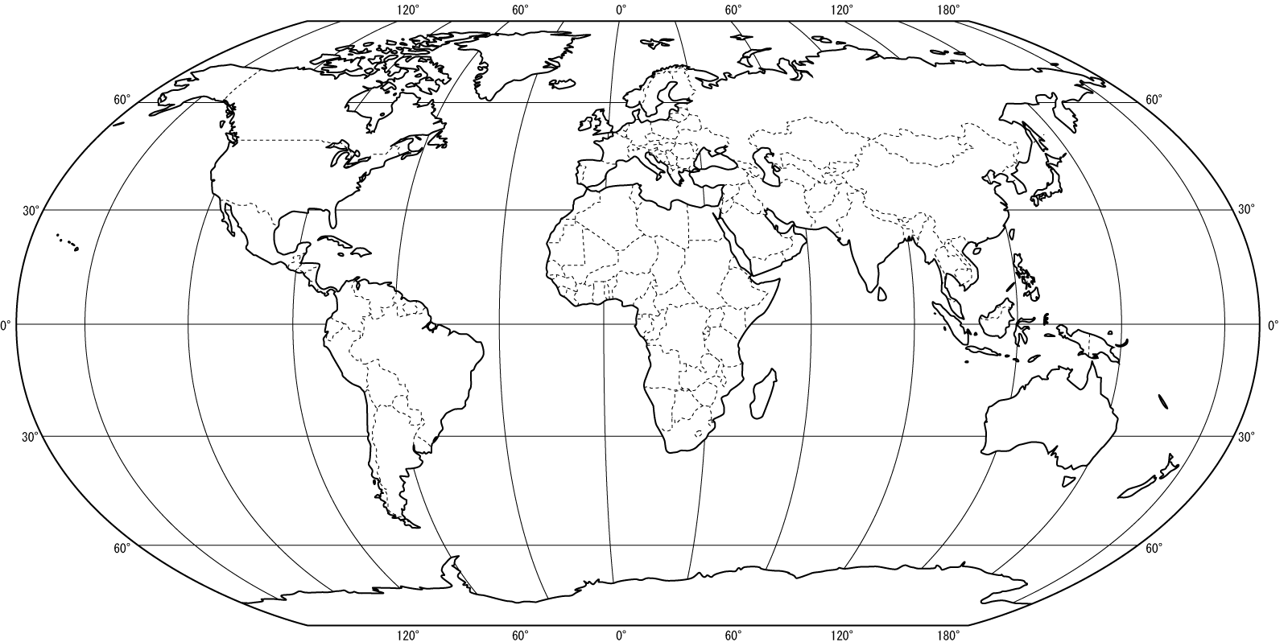

- Create bullet style notes about the current remaining colonies. Focus on where these remaining colonies are, what states control them and why they choose to do so. Also, what fairly recent changes have occurred with colonial possessions?

