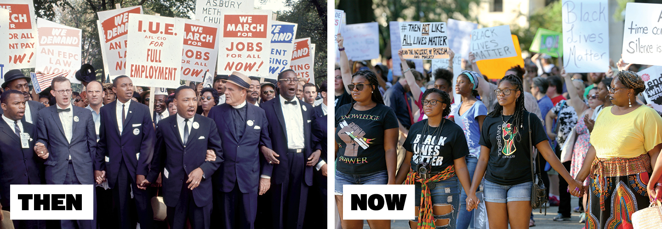
MLK 50 Years Later: Upfront Magazine 01/29/18 by Brooke Ross
The 1968 assassination of Martin Luther King Jr. stunned the nation, but his work continues to inspire the pursuit of racial equality in America
On Aug. 28, 1963, more than 250,000 people gathered on the National Mall in Washington, D.C., to hear what is now considered one of the most powerful speeches in history. A young Baptist minister named Martin Luther King Jr. addressed the crowd that had assembled for the March on Washington, a protest rally he had helped organize. “I have a dream,” King said, “that one day this nation will rise up [and] live out the true meaning of its creed: We hold these truths to be self-evident, that all men are created equal.” His words were an impassioned call for racial equality for African-Americans. At the time, in parts of the country—especially in the South—blacks couldn’t eat at certain restaurants, still had to attend segregated schools (though the practice had been outlawed years earlier), and were unemployed at a rate nearly twice that of whites.
The march—a prime example of the nonviolent protest King advocated—helped secure passage of the Civil Rights Act of 1964. The landmark legislation banned discrimination in the workplace and in all places of public accommodation, including parks, restaurants, and hotels. The act was one of many civil rights milestones in which King played a key role (see Timeline, below).
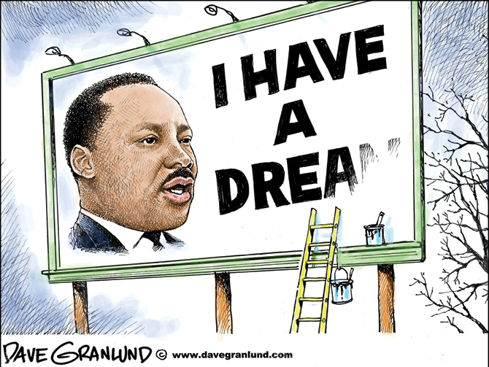
But just a few years later, as King was shifting his attention toward poverty issues and housing rights for African-Americans, his life was tragically cut short. On April 4, 1968, he was assassinated in Memphis, Tennessee, at the age of 39. Millions around the nation mourned King. “The heart of America grieves today,” said President Lyndon B. Johnson. “A leader of his people—a teacher of all people—has fallen.”
Today (January 2018), as the U.S. prepares to mark the 50th anniversary of King’s death, important strides have been made toward achieving civil rights for all Americans. But many people believe the nation continues to struggle with racial discrimination. Even as King’s legacy has influenced a new generation of activists, his long-ago dream of equality has yet to be fully realized, says Hasan Jeffries, a professor of African-American history at Ohio State University. “The very same issues that people are wrestling with now—police violence and unarmed African-Americans being killed, people taking to the streets for affordable housing—are the same issues King was wrestling with then,” Jeffries says.
Before the Dream:A native of Atlanta, King never intended to be the face of the civil rights movement. He started out as a minister in Montgomery, Alabama, in 1954, nearly a century after the Civil War (1861-65) and the end of slavery. Yet throughout the South, segregation prevailed, with Jim Crow laws systematically discriminating against black people politically, economically, and socially. Though he had little experience in activism, King—who had a Ph.D. in theology from Boston University—was known as a brilliant public speaker. In 1955, community leaders recruited him to be the spokesperson for the Montgomery bus boycott, which was sparked by Rosa Parks’s refusal to give up her seat to a white passenger and became one of the first major protests of the civil rights era. The boycott lasted for more than a year, ending only after a U.S. Supreme Court ruling that declared racial segregation on public buses unconstitutional. King’s role in that boycott transformed him into a national figure. In 1957, he co-founded the Southern Christian Leadership Conference to encourage other communities to take up the crusade for civil rights. In addition to helping achieve passage of the Civil Rights Act, King played a pivotal role in securing voting rights for African-Americans. In 1965, he helped organize high-profile marches from Selma, Alabama, to the state capital of Montgomery. This protest and others led to President Johnson signing the Voting Rights Act of 1965. That law made literacy tests and other obstacles to black voter registration illegal.
As one of the most recognizable faces of the civil rights era, King was a target of those who opposed the movement. He was beaten and jailed, and his home was bombed. He received frequent death threats. Yet even in the face of such violence, King remained peaceful, says biographer David Garrow. “King was first and foremost a preacher,” Garrow says. “He would always insist upon distinguishing between the evil deed and the evildoer. He was incapable of hating.”
Struggles and Setbacks: Though King is revered today, that wasn’t always the case when he was alive. Many young people thought his methods were too passive and pushed for a more aggressive approach. Many older people, on the other hand, believed King was too radical. In a 1967 poll, only 32 percent of Americans said they approved of him. Still, King continued to speak out, even taking a stand in 1967 against U.S. involvement in the Vietnam War (1965-75). His position drew widespread condemnation. “King was willing to say things that he knew . . . would make him less popular,” Garrow says.
By the spring of 1968, King had begun campaigning for housing rights for people of color. He was also preparing to stage a massive rally in Washington to raise awareness about poverty. “What good is having the right to sit at a lunch counter,” he asked, “if you can’t afford to buy a hamburger?” King, however, didn’t get far with these efforts. On April 4, while in Memphis, he was shot dead on the balcony of his motel. A small-time criminal named James Earl Ray confessed to the killing, though his motives were never clear. (Ray died in prison in 1998.) Within days of King’s death, Congress passed the Fair Housing Act. The new law—which banned discrimination in housing—was seen as a tribute to King’s efforts in his final years.
More Work to Do: King’s work helped pave the way for many important African-American firsts, including the appointment in 1967 of Thurgood Marshall, the first black justice to serve on the Supreme Court, and the election of the first black U.S. president, Barack Obama, in 2008. Still, America continues to struggle with some of the same problems that King faced. Statistics show, for example, that many blacks lack the same economic or educational opportunities as whites and live in less-wealthy neighborhoods. Also in recent years, police killings of unarmed African-Americans have made headlines and ignited massive protests. According to a 2016 analysis by The Washington Post, blacks are 2.5 times as likely as whites to be shot and killed by law enforcement officers.
Many people believe that if King were alive today, he would support the groups protesting for change in 2018, including NFL players who kneel during the national anthem to draw attention to police brutality; fast-food workers demanding a wage increase; and the Black Lives Matter movement, which seeks to end discrimination in the criminal justice system. Also, experts say, King would be reminding us that many of the positive changes that have happened in this country came about because people were willing to fight for them. “You don’t need a lot of people to make an impact,” Jeffries says. “[When] a small fraction of people organize and come together and speak with one voice, they can make a big difference.”

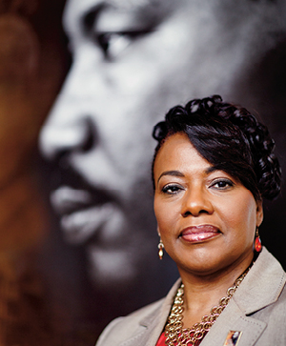
Her Father’s Legacy

Photo by Melissa Golden/Redux

Bernice King was 5 years old when the civil rights icon was assassinated.
Do you have memories of your father?
They’re very faint. I had just turned 5 prior to his assassination. He was traveling a whole lot. [But] he loved playing with us. We were like his refuge from all the seriousness of the work he was doing to bring about change in the world.
How old were you when you realized how important your father was?
About 16. I went on a retreat with my church . . . and I suggested that we watch [a documentary about him]. I ended up in tears. I understand it better as an adult, that they were fulfilling their purpose, although I still really wish I had my father.
What would your father be doing if he were alive today?
He was in the middle of trying to address poverty in America. We [still] have serious racism, but poverty is a monster. I think that would be a heavy focus for him and had he lived, we would see a drastic difference today.
This interview was conducted by Joe Bubar and has been edited for length and clarity.
Timeline: The Civil Rights Era
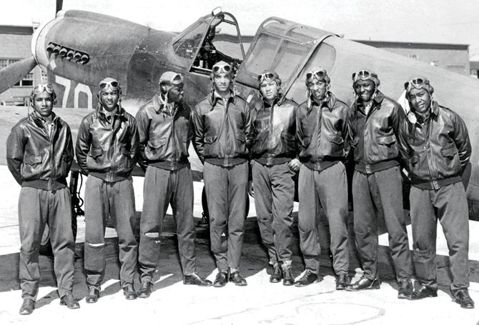
Photo: (A724/Gamma-Rapho via Getty Images) The Tuskegee Airmen, a black Army Air Corps unit during World War II
1948: The Military: President Harry S. Truman issues an executive order to desegregate the U.S. armed forces. After widespread resistance in the military, the last all-black unit is dissolved in 1954.
1954: Brown v. Board of Ed: The U.S. Supreme Court rules that segregated public schools are unconstitutional, overturning the “separate but equal” standard established in 1896.

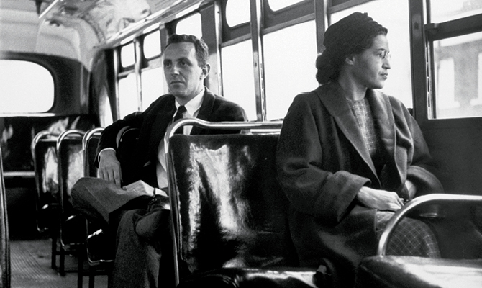
Photo: (Bettmann/Getty Images) Rosa Parks in December 1956, after helping end segregation on Montgomery buses
1955: Bus Boycott: Rosa Parks is arrested in Montgomery, Alabama, for refusing to give up her seat to a white passenger on a bus. This sparks a boycott of city buses, led by Martin Luther King Jr.
1957: Little Rock Nine: Nine black students attempt to desegregate Central High School in Little Rock, Arkansas. They’re turned away by an angry mob. Federal troops eventually escort the students inside.
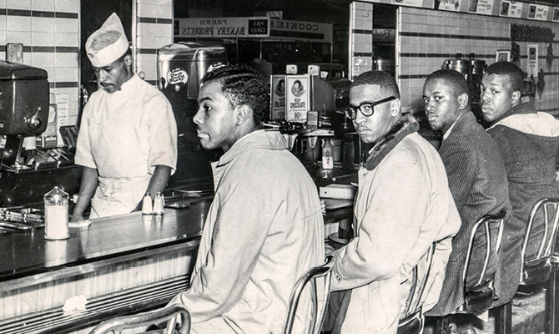
Photo: (Jack Moebes/Greensboro News & Record Staff Photographer)
1960: Greensboro: Four black college students in North Carolina (above) stage a sit-in at an all-white lunch counter. The protest helps galvanize young blacks across the U.S.
1963: ‘I Have a Dream’: Martin Luther King Jr. delivers his famous “I Have a Dream” speech to more than 250,000 people at the March on Washington in Washington, D.C.
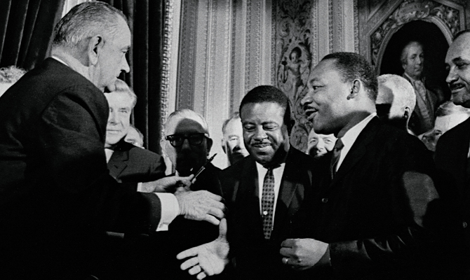
1964: Civil Rights Act: President Lyndon B. Johnson signs the Civil Rights Act of 1964, outlawing segregation in public places and employment.

Photo: (Corbis Historical/Getty Images) President Johnson with Martin Luther King Jr. after signing the bill at the U.S. Capitol).

August 1965: Voting Rights Act: Congress outlaws literacy tests, poll taxes, and other obstacles to black voter registration (above,

Analyze the Article: Questions to discuss… Prepare your answers below…
1. How did MLK, Jr. become a national civil rights figure? What skills did he possess that proved useful?

2. What were the key issues King focused on during the civil rights movement?

3. If King were alive today, what issues do you believe he would focus his efforts on? Why those?

4. How has King affected the world we live in today? What is his legacy?

