AP Human Geography – Chapter 8.4: Why do States Cooperate & Compete – The Cold War (Secondary Source)
How the Russian Revolution Changed the World – Upfront 12/11/2017 by Veronica Majerol
One hundred years ago (1917), a peasant uprising toppled an empire, with far-reaching consequences. A look at how it transformed history. It was a defining event of the 20th century. One hundred years ago, in the fall of 1917, Communists known as Bolsheviks seized power in Russia, ending 1,100 years of imperial rule in the world’s largest nation.
Russia had long been run by despotic czars, and in the early 1900s, peasants began to revolt. When Russia’s economy, military, and government collapsed under the pressures of World War I (1914-18), Russia’s final czar, Nicholas II, was forced to abdicate his throne in March 1917. That created an opening for the charismatic Bolshevik leader Vladimir Lenin to seize power by November, soon establishing the Union of Soviet Socialist Republics, also known as the Soviet Union.
Within decades, Soviet rulers—including the infamous Joseph Stalin, who killed millions of Soviets as part of a political purge—transformed the country into a fearsome military power. It engaged the U.S. in a decades-long struggle for global dominance—a “Cold War” not just over territory, but also the very survival of Western democracy. For much of the 20th century, the Soviet threat loomed over every aspect of American life, from politics to technology to pop culture, until it collapsed in 1991.
“To try to understand the 20th century without the Russian Revolution is like one hand clapping,” says Lewis Siegelbaum, a Russia expert at Michigan State University. With that in mind, here’s a look at seven ways the Russian Revolution changed the world.
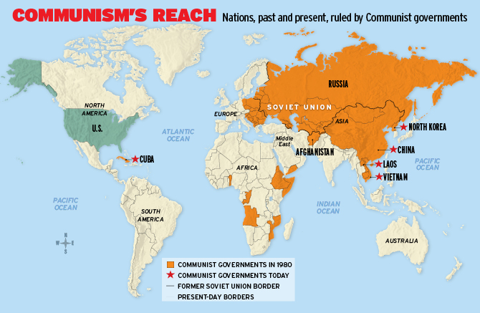
1. The Cold War: Though Communism ran contrary to America’s values, the U.S. and the Soviet Union joined forces during World War II (1939-45) to defeat Nazi Germany. But after the war, it became clear that Moscow was intent on taking over vast sections of Eastern Europe and installing Communist puppet regimes. What followed was the Cold War—a decades-long competition pitting capitalism and democracy, embraced by the U.S. and its allies, against Soviet authoritarianism and Communist rule.
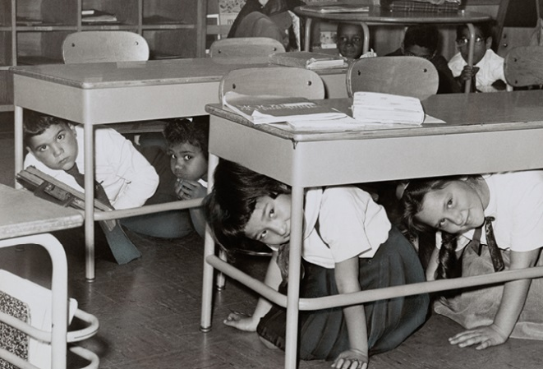
When some countries began to “fall” to Communism, as China did in 1949, the U.S. grew more concerned about the “domino effect,” the idea that if one country becomes Communist, others will follow. There was also fear of infiltration by an “enemy within”—foreign spies and American Communists—heightened by Senator Joseph McCarthy’s overheated witch hunts in the 1950s for alleged Communists in the State Department and Hollywood. Movie stars and others were summoned before congressional committees and ordered to name colleagues who were Communists. Many suspected of Communist sympathies were “blacklisted” and lost their jobs. “The idea that actors and some workers could get together and overthrow the United States government—some people took that seriously,” says Andrew Straw, a Russia scholar at the University of Texas at Austin, “because there was a clear example of it in 1917.”
Jim McMahon
Photo: GraphicaArtis/Getty Images
Duck & Cover: Middle school students in Brooklyn, New York, during a practice drill for a nuclear attack, 1962

2. Nuclear Buildup: The U.S. became the first country to successfully develop and use a nuclear bomb in war, in 1945 (created by by the Manhattan Project ), but its nuclear monopoly abruptly ended in 1949, when it became clear that the Soviet Union had tested an atom bomb of its own. Thus began the nuclear arms race between the Soviet Union and the U.S., with each side determined to have a bigger and stronger nuclear arsenal.
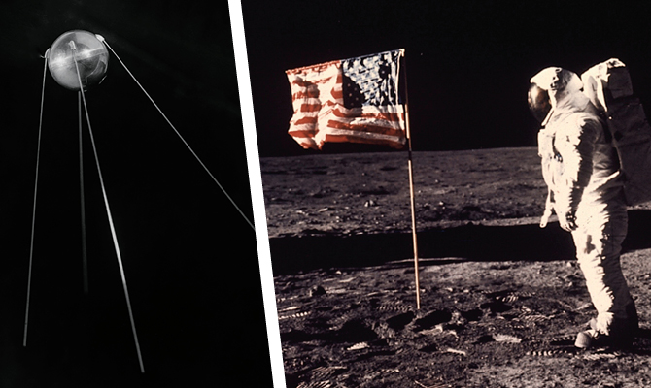
“Duck and cover” drills became standard in schools, with children practicing huddling under their desks in case of a Soviet attack (as if a school desk could shield someone from a nuclear bomb). Ironically, the idea of “mutually assured destruction,” or MAD, kept each side from ever using their nuclear weapons on each other for fear of being wiped out in retaliation. But the nuclear buildup continued, in these two countries and elsewhere: Today, nine nations have nuclear weapons, including North Korea, led by the rogue dictator Kim Jong Un (see No. 4).
Photos on left: Sputnik 1, the first artificial Earth satellite, launched by the Soviet Union in 1957 (left); and American astronaut Buzz Aldrin during the 1969 moon landing (Neil Armstrong held the camera.)
Sovfoto/UIG via Getty Images (Sputnik 1); Neil A. Armstrong/AP Images (Buzz Aldrin)
3. Space Race: Though America was the first to develop the nuclear bomb, the Soviet Union soon celebrated its own first, which stunned—and frightened—the U.S.: In 1957, the Soviets launched Sputnik, the world’s first unmanned artificial satellite, ushering in the space age. The next year, America followed suit with its own satellite, and President Dwight D. Eisenhower created NASA (the National Aeronautics and Space Administration), which was dedicated to space exploration. Then, in 1961, the Soviets led the way again, putting a man into space for the first time and returning him home unharmed.
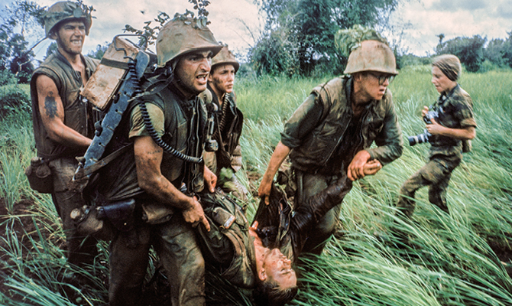
In 1962, in a speech at Rice Stadium in Houston, Texas, President John F. Kennedy declared America’s commitment to being the best and doing something the Soviets hadn’t yet done. “We choose to go to the moon in this decade and do the other things [that challenge us], not because they are easy, but because they are hard.” Kennedy’s promise was fulfilled in 1969, when U.S. astronauts Neil Armstrong and Buzz Aldrin became the first men to walk on the moon, giving America the victory in the space race—and bragging rights in the Cold War. Today, the spirit of the space race continues, with NASA preparing to send humans to Mars by the 2030s.

Photo: U.S. troops in Vietnam, 1966, Larry Burrows/The LIFE Picture Collection/Getty Images

4. Vietnam & Korean Wars: The U.S. and the Soviet Union never actually engaged in direct combat during the Cold War. But they fought a number of “proxy wars”—contributing weapons, money, or soldiers to military efforts that aligned with their values. That was the case during the Korean War (1950-53), when the U.S. fought alongside the South against Communist forces in the North, supported by the Soviet Union. America lost 34,000 soldiers in the Korean War, which ended in a stalemate and split that country in two: democratic South Korea and Communist North Korea. They signed an armistice, but not a peace agreement, so they technically are still at war. And North Korea remains a totalitarian Communist regime with nuclear weapons that threatens the U.S.
In Vietnam, where civil war broke out in the 1950s, America was also determined to prevent a Communist takeover and began sending advisers to help the South Vietnamese. The U.S. escalated its involvement in 1965, when it started sending combat troops into Vietnam. The war was controversial and tore the U.S. apart. Many Americans, especially teenagers and college students, protested the war and the draft, questioning America’s presence in the faraway conflict. By the war’s end in 1975, more than 2.5 million Americans had served in Vietnam and 58,000 had died. The Communists won, which was a crushing blow to the U.S. that left it cautious about future military entanglements. Vietnam remains a Communist country, but, like China, which also remains Communist, it has embraced some free-market reforms and is a vital trading partner of the U.S.
5. Pop Culture: As the U.S. and the Soviet Union engaged in a battle to win the hearts and minds of the rest of the world, America sought to portray itself as a bastion of freedom and prosperity. One manifestation was the Barbie doll, created in 1959. Outfitted with dresses, swimsuits, and sunglasses, the doll represented a sharp contrast to the way of life in the Soviet Union, where the centrally planned Communist economy for many years focused more on agriculture, defense, and housing than it did on consumer goods. In 1964, a year before U.S. combat troops were sent to Vietnam, American boys got a doll of their own. Equipped with machine guns and bazookas, G.I. Joe grossed $16.9 million in its first year. (Its popularity waned in the latter years of the Vietnam War, however.) And George Orwell’s 1984, a book still widely read in U.S. high schools, also grew out of the Cold War. Published in 1949, the novel expressed the British author’s anxieties that the competition between the U.S. and the Soviet Union for global supremacy would lead to totalitarian states around the world, with “Big Brother” controlling our every move.
6. Al Qaeda & 9/11: On Christmas Eve in 1979, the Soviet Union invaded Afghanistan to rescue a Communist-leaning government under attack by Islamic rebels, known as mujahedeen, or “holy warriors.” To hurt its Cold War foe, the U.S. began arming the mujahedeen in the 1980s, helping them secure a stalemate against the Soviet army, which finally pulled out its troops in 1989. With the Soviets gone, factions of mujahedeen battled each other. By 1996, the Taliban, a radical Islamist group, controlled the country. Among those who’d joined the mujahedeen was Osama bin Laden, a billionaire’s son from Saudi Arabia. Angered by Soviet and American involvement in Middle East affairs, he helped found the terrorist group Al Qaeda. Bin Laden would become the mastermind of the Sept. 11, 2001, attacks, which killed nearly 3,000 Americans. The attacks drew America into two wars, in Afghanistan in 2001 and in Iraq in 2003. The U.S. still has roughly 11,000 troops in Afghanistan, making the war there America’s longest. Today, part of the U.S. mission there is to weaken the terrorist group ISIS, which traces its roots to one of the radical groups that emerged in Iraq following the 2003 American invasion.

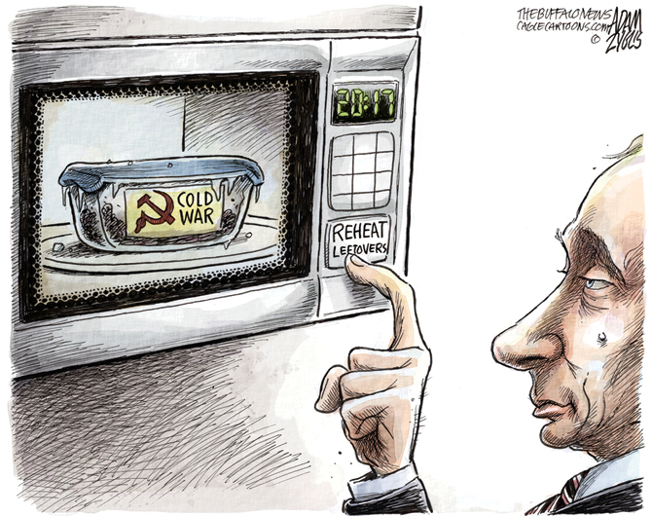
Cartoon (right): Adam Zyglis, The Buffalo News/PoliticalCartoons.com
7. Putin and a New Cold War? In the end, the Communist model didn’t work out for the Soviet Union, which collapsed in 1991, despite efforts by then-Soviet leader Mikhail Gorbachev to loosen the economy and enact other reforms. The Russian democracy that succeeded his rule was well-meaning but incompetent. In 2000, after a decade of economic chaos, Vladimir Putin—a veteran of the Soviet Union’s spy service, the KGB—took power in a peaceful transfer of authority, promising stability and casting himself as a democrat.
Putin wants to return Russia to the superpower status of the Soviet era. He has stayed in power ever since and has proved himself an authoritarian. During his rule, political opponents have been jailed or murdered, free speech has been curtailed, and in 2014, amid political upheaval in neighboring Ukraine, Putin forcefully annexed the territory of Crimea. More recently, U.S. intelligence officials say Putin personally sought to undermine American democracy by meddling in the 2016 presidential election, seeking to boost Donald Trump’s chances. During the czarist era and Soviet years, Russia was a superpower that the U.S. and the rest of the world couldn’t ignore. And according to Sean Guillory, a Russia expert at the University of Pittsburgh, Putin wants that again. “His end goal,” says Guillory, “is to bring Russia back to become a major global player.”
With reporting by Michael Wines of The New York Times.

Questions to Answer in full sentences. Be Prepared to Discuss.
1. Identify and explain TWO short term effects of the Russian Revolution of 1917.

2. Define the Cold War in your own words AND explain TWO reasons why it occurred.

3. Identify and explain THREE ways the Cold War impacted the USA and / or the world.

4. Analyze the political cartoon by Adam Zyglis. How does image align the text in Section 7 of the article above?

