AP Human Geogrpahy: Chapter 9 Development – The Fight Over Fracking – Upfront 02/20/17 by Amy Barth
The controversial drilling method has spurred a boom in U.S. oil production. But does it harm the environment—and people’s health?
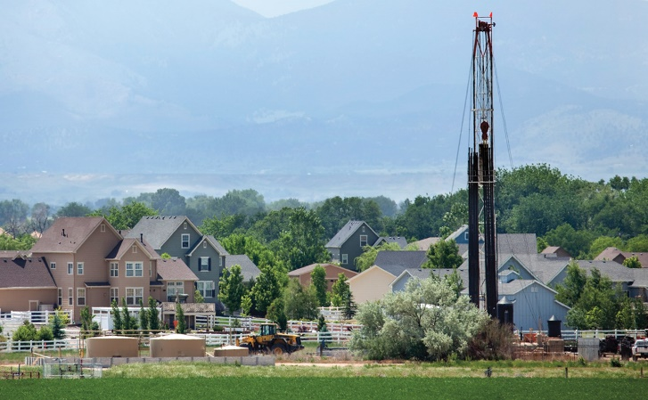
Adjacent Photo: A drilling rig used for fracking near homes in Colorado – Getty Images
iStockPhoto.com/Getty Images
In 2005, Linda and David Headley purchased their dream home, a 115-acre ranch with hills, trees, and grassy farmland in Fayette County, Pennsylvania. A creek runs through their property, and a freshwater spring supplied them with water. It seemed like the perfect place to raise kids. But suddenly, in 2007, bulldozers began appearing on the Headleys’ property. Trucks arrived carrying water, chemicals, and sand. Workers began drilling holes in the land. They were using a technique called hydraulic fracturing, or fracking, to extract oil and natural gas trapped deep underground in a type of rock called shale. The oil and gas would eventually be used as fuel to heat buildings, cook food, power cars, and generate electricity.
When the Headleys bought the ranch, they didn’t buy the property’s oil and gas rights from the previous owner. Without their knowledge, the owner had rented the rights to gas companies before the Headleys moved in. Those rights allow workers to legally enter the property at any time to remove oil and gas.
Around the same time that the fracking began, the Headleys started having health problems. “I sometimes have trouble breathing,” says Linda. “My oldest son [Grant] gets rashes. My youngest son is only 8 and he gets horrible stomach aches and nosebleeds.” The family blames its health problems on pollution from fracking. Oil and gas unearthed during the fracking process—and likely some chemicals used to help extract those resources—leaked onto their land and into their water supply. Several of the Headleys’ neighbors, who also have wells on their land, have gotten sick too. “Before this started, we were all healthy,” says Linda.
Today, the Headleys’ property has five fracking wells. The freshwater spring they once relied on for water is now so cloudy they can’t drink from it. For a while, they had to bring in truckloads of clean water from Linda’s mom’s house, two miles away. The spring their horses once drank from is so rich with gas that it can be set on fire. And they’ve had to rescue their dog, Banjo, from a puddle of sludge in their yard.
In the past decade, stories like the Headleys’ have become increasingly common. They’re now at the center of a nationwide debate about whether fracking should be allowed in the United States. Supporters of fracking say it has unlocked a tremendous amount of oil and natural gas in the U.S., created tens of thousands of jobs, and brought money to communities that desperately need it. It, along with other factors, has also helped lower the price of gas in the U.S.
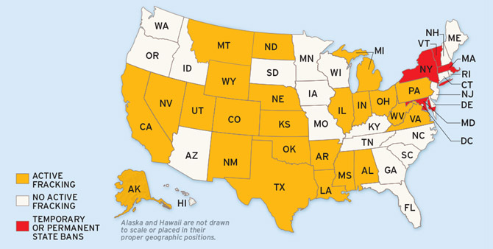
FRACKING NATION: Active wells and fracking bans
Map Source: Jim McMahon; Inside Climate News Research; State Agencies
But the technique has also raised health and environmental concerns. In December, the Environmental Protection Agency concluded for the first time that fracking can contaminate drinking water. The technique has become so controversial that some states—including New York and Vermont—have banned it (see previous map). Many people are left wondering: Is fracking worth the risks?
The U.S. lies atop more than a dozen large shale formations, which contain huge amounts of oil and natural gas. To get to those resources, fracking companies drill about a mile underground to reach the rock (see diagram). Then they inject millions of gallons of water—mixed with sand and chemicals—into the shale at very high pressure. The pressure creates small cracks, or fractures, within the rock, which release the gas and oil trapped inside. Workers then capture and sell the fuel. Fracking has existed since the 1940s, but the technology has greatly improved in recent years. Today, it generates more than half of all oil produced in the U.S., up from less than 2 percent in 2000. The vast majority of fracking—about 90 percent—takes place on state and private property, where the federal government has little control. Each state has its own fracking rules. Some require that companies fully disclose the chemicals they use, while others have few regulations.
Benefits & Harm: Supporters of fracking say the process is safe and that the oil and gas industry follows guidelines to prevent water contamination. Plus, they say, the method has brought huge benefits to the U.S. and local communities. For one, it has made the U.S. less dependent on foreign oil, a goal the U.S. has been working toward for decades. Though the U.S. has long been a major producer of oil, it also uses more of it than any country in the world, requiring it to buy oil from other countries. But many of the countries we rely on for oil, including Russia and Venezuela, are unstable or hostile to the U.S. Fracking has helped the U.S. produce more oil domestically, protecting us from global disputes and spikes in prices. The natural gas mined during fracking can also help the U.S. transition away from coal, a “dirty” fossil fuel. Coal produces carbon dioxide, which scientists believe is a major contributor to climate change. Natural gas releases much less carbon dioxide and is considered cleaner. Fracking has also brought money and jobs to some of the poorest parts of the country. With thousands of workers from the oil industry flowing into struggling communities, new restaurants, stores, and hotels have opened to accommodate them.
The small town of Carrizo Springs, Texas, is one of the many places that have benefited from fracking. Lydia Seiple used to have to drive miles out of town to get to a supermarket. But after fracking companies began drilling in the area, a big grocery store was built near her home. In 2014, Seiple’s husband got a higher-paying job working security for an oil company. “It’s made a huge difference for us,” says Lydia, who volunteers for the Girl Scouts and helps youth in foster care. “Now we have time to volunteer as a family and are able to donate money.”
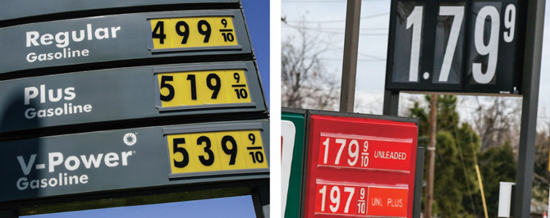
Despite the benefits of fracking, many people think they don’t outweigh the risks. Experts say thousands of cases of water contamination linked to the fracking process are documented each year. In many instances, families that live near drilling locations—like the Headleys—have reported experiencing stomach aches, rashes, dizzy spells, and difficulty breathing. Dust, noise, and light from drilling can also pollute the environment. In addition, once a fracking project is complete, millions of gallons of wastewater come to the surface and must be disposed of. A common disposal method has been injecting wastewater back underground, which is thought to have triggered dozens of small earthquakes in Oklahoma, Ohio, and other states.
Tony Avelar/Bloomberg via Getty Images (2008 gas prices); Sue Ogrocki/AP Images (2016 gas prices)
Gas is much cheaper today in part because fracking has increased the nation’s fuel supply. It’s the law of supply and demand at work: When the supply of something exceeds the demand, prices tend to drop.

A Slowing Boom? Gretchen Goldman of the Union of Concerned Scientists says natural gas contains the chemical methane, which can leak into the air during fracking. Methane is a gas that traps heat in the atmosphere, causing Earth’s average temperature to rise. “Fracking has helped reduce our reliance on coal, but it’s still contributing to climate change,” she says. “Long term, we should think about how to move on to clean energy like solar, wind, and water power.” Several national, state, and local officials are now grappling with whether to allow fracking. Last September, a federal judge blocked the U.S. Bureau of Land Management from opening more than 1 million acres of federal land to fracking in central California. Two months later, the oil and gas industry won a victory when environmentalists in Colorado failed to get enough public support to put two anti-fracking measures on the ballot. One would have made it illegal to frack less than 2,500 feet from buildings, waterways, as well as open public spaces like parks. President Donald Trump has also weighed in on the controversy. On the campaign trail, he pledged to expand fracking and roll back regulations. “The shale energy revolution will unleash massive wealth for American workers and families,” he said in a speech to fracking executives last fall.
But the fracking boom—and the surge in U.S. oil production—may be slowing, at least temporarily. The U.S. produced so much oil in the past few years that there’s now more supply than demand. That and other factors have caused oil prices worldwide to drop about 50 percent since mid-2014. Some fracking wells in the U.S. have shut down, and tens of thousands of workers have lost their jobs. Experts, however, say prices will likely go back up at some point, since oil prices constantly rise and fall.
Regardless of the demand for oil, Goldman says more studies need to be done to determine exactly how fracking affects the environment and public health so that governments can make informed decisions. “Every person and community has different needs,” she says. “When it comes to allowing fracking, everyone needs to weigh the information and make a decision that’s right for them.”
The Fracking Process
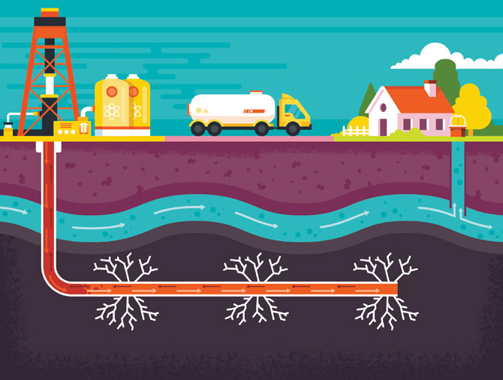
1) Workers drill a deep vertical hole into a shale formation. Then they drill horizontally through the shale and insert a pipe.
2) Cement is placed around the pipe to try to prevent groundwater contamination
3) Water, sand, and chemicals are injected into the pipe at very high pressure, which forces the shale to fracture, or break up
4) Oil and gas flow through the cracks and back up the well

Close Reading Activity: The Fight Over Fracking – After closely reading the article and annotating key ideas answer the questions below in the space provided.
- Define fracking and explain why oil companies have turned to this technique in the USA
____________________________________________________________________________________________________________________________________________________________________________________________________________________________________________________________________________________________________________________________________________________________________________
- Use evidence from the text [either a brief quote or paraphrase, citing the paragraph number] to explain why it is difficult for the federal government to regulate fracking.
____________________________________________________________________________________________________________________________________________________________________________________________________________________________________________________________________________________________________________________________________________________________________________
- The USA have been working toward energy independence. Based on the text, what do you believe it means to be energy independent, AND what are its possible advantages?
____________________________________________________________________________________________________________________________________________________________________________________________________________________________________________________________________________________________________________________________________________________________________________
- Summarize the key arguments FOR and AGAINST fracking. Which side of the argument do you believe makes the most sense? Why?
FOR______________________________________________________________________________________________________________________________________________________________________________________________________________________________________________________________________________AGAINST__________________________________________________________________________________________________________________________________________________________________________________________________________________________________________________________________________
OPINION___________________________________________________________________________________________________________________________________________________________________________________________________________________________________________________________________________________________________________________________________________________________________________________________________________________________________________________________________________________________________________________________________________________________
- How does the author support the claim that the fracking boom “may be slowing?” Cite evidence.
_______________________________________________________________________________________________________________________________________________________________________________________________________________________________________________________________________________________________________________________________________________________________________________________________________________________________________________________________________

