AP Human Geography: Chapter 9 Development – Gender Inequality Issues – adapted by Newsela staff 01/09/18
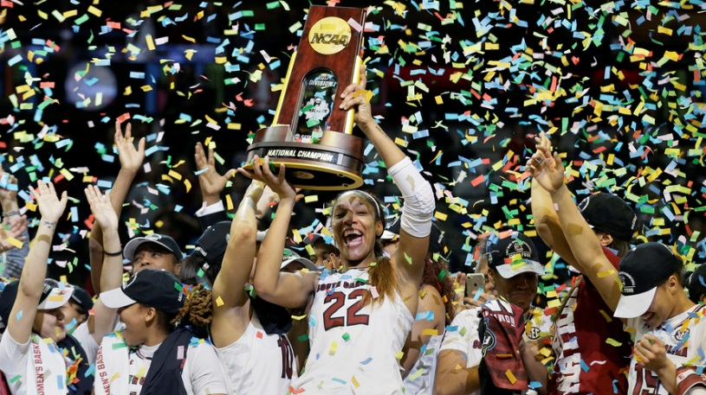
How Title IX works: Gender equality in education (Word Count 1319)
Adjacent Image: South Carolina forward A'ja Wilson (22) holds the trophy as she and her teammates celebrate a win over Mississippi State in the final of NCAA women's Final Four college basketball tournament, April 2, 2017, in Dallas, Texas. South Carolina won 67-55. AP Photo/Tony Gutierrez
Adjacent Image: Billie Jean King in New York, 1978. Photo: Lynn Gilbert/Wikimedia.
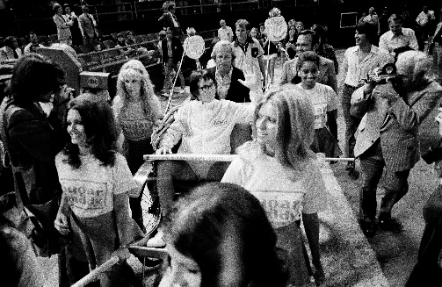
The Houston Astrodome, 1973. More than 30,000 roaring sports fans crowded the tennis court as a 55-year-old retired tennis legend Bobby Riggs arrived in a cart pulled by female models. Riggs, once the No. 1 player in the world, was a proudly sexist athlete. He was so convinced of the superiority of men that he had challenged the great Billie Jean King to a "Battle of the Sexes." King had also been ranked No. 1 in the world and won 12 career Grand Slam singles titles, including five at Wimbledon by 1973. But feminism was still a fringe movement at the time. Most women couldn't even get their own credit card without having a man's approval. Title IX, the law that outlaws discrimination based on sex in education, had only been around for a year.

Women Faced Inequality In Education: Adjacent Image: Bobby Riggs, riding in a rickshaw pulled by some women, makes his grand entrance to the Astrodome in Houston, Texas, September 20, 1973, for his $100,000 winner-take-all match with Billie Jean King. Before the night was over, Riggs left the court a defeated man after losing the championship to King, 6-4, 6-3, 6-3. (AP Photo)
Before Title IX became law in 1972, women faced inequity at every turn in the world of education. School athletics epitomized that inequity. When Billie Jean King went to college, she couldn't get a sports scholarship because there simply were none for women back then. And the problems started much earlier. Female tennis players at one high school, for instance, had to buy their own uniforms and equipment. They were expected to keep quiet about their success as a team even though they had an amazing winning record.
Equality among men and women needed a champion and it got one when King took Riggs up on his challenge. Riggs had been provocatively declaring that women weren't emotionally equipped for athletics, and that they were better off in the kitchen where they belonged. King later said she knew that if she had lost, it would have been a blow to feminism, women's tennis and Title IX. In other words, she had to win. That day at the Astrodome, King emerged on a golden throne carried by bare-chested men. She then demolished Riggs, 6-4, 6-3, 6-3. The "Battle of the Sexes" became the first big win for women in athletics in the Title IX era.

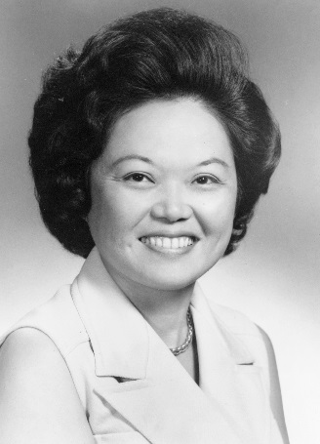
The Origin Of Title IX: Patsy Mink is often called "the mother of Title IX." At
Adjacent Image: Patsy Mink when she was a member of the U.S. House of Representatives between 1970 and 1977. Photo: United States Congress.

Hawaii's Maui High School in the early 1940s, she wasn't allowed to play full-court basketball because back then everybody was sure that so much running would be too hard on girls. Mink also faced discrimination in college and graduate school. She eventually became a lawyer and then the first woman of color to be elected to the U.S. House of Representatives in 1964. In 1972, Mink helped add Title IX to a set of laws called the Education Amendments. Title IX is about a page long. It begins with these words: "No person in the United States shall, on the basis of sex, be excluded from participation in, be denied the benefits of, or be subjected to discrimination under any education program or activity receiving Federal financial assistance." Few at the time understood the sweeping changes Title IX would bring about. Then, in 1973, King helped make it international news. The "Battle of the Sexes" highlighted the huge difference between the opportunities men and women had experienced at all levels in U.S. sports.

The Evolution Of Title IX: The passage of Title IX remade the sports landscape. For instance, female athletes in college could suddenly get scholarships that older women like King had been denied. According to the Women's Sports Foundation (which was created by King) by 1978, the number of high school girls playing competitive sports had multiplied six times. North Carolina State University spent 15 times more on women's sports than what it had in 1974. The University of Michigan had 10 varsity women's teams, up from zero just five years earlier. In 1972, 1 in 27 young women took part in sports. Today, that number is 2 in 5. As a result, women have enjoyed better health and improved academic and professional success.
There have been more than 20 attempts in Congress to change or get rid of Title IX. In the decades since it was signed into law, the spending on some traditional male college sports like wrestling, gymnastics, baseball and track have been severely cut. A few programs have even been ended. Some coaches, athletes, and fans have blamed Title IX for this trend. The argument goes like this: Title IX requires colleges to spend money on women's sports in proportion to the students attending school rather than team participation. That means that even though a smaller percentage of women participate in college sports, less-popular men's sports have lost funding.
Adjacent Image: Rutgers University playing against U.S. Naval Academy in 2004. Colleges and universities have blamed cuts in budgets on Title IX, but those cuts are likely related more to the huge expenses of NCAA football and basketball teams. Photo: Damon J. Moritz/Wikimedia.
In truth, the decisions to cut men's programs have more to do with the mushrooming expense of maintaining NCAA football and basketball teams than Title IX requirements. In fact, most colleges still spend considerably more on men's sports. Title IX simply requires that schools not discriminate against girls' and women's sports. If a women's hockey team has substandard equipment and facilities compared to the men's team — that's discrimination. That means it's illegal under Title IX. This basic idea of fairness could be the reason why Title IX is overwhelmingly popular.

Title IX, Campus Sexual Harassment & Sexual Assault: For its first 25 years, Title IX was mostly about women and sports. But it now touches on other issues. This started in 1980 when a U.S. federal court decided that Title IX made campus sexual harassment unlawful. Sexual harassment occurs when someone makes unwelcome sexual advances or comments. Title IX has also been used to police campus sexual assault. Sexual assault is when someone makes unwanted sexual contact, including rape. In 2014, the Obama administration clarified how schools should handle campus sexual assault cases in reference to Title IX. Many hailed this as a step forward in combating sexual assault. However, many critics said those accused of crimes were not receiving legal protections guaranteed under the U.S. Constitution. In 2017, the Trump administration rolled back the Obama-era rules.

Much Work Still To Be Done: Despite these disputes, Sarah Axelson of the Women's Sports Foundation says Title IX has been a helpful law. She said Title IX has had a remarkable Despite these disputes, Sarah Axelson of the Women's Sports Foundation says Title IX has been a record of success at all levels of education for girls and women. Still, she adds, there's much work to be done. Remember those three girls out of every five who aren't participating in sports? The Women's Sports Foundation seeks to ensure that those women are not playing sports as a matter of choice rather than lack of access.

Image 6. In 2016, about 300 people gathered outside TCF Stadium on the campus of the University of Minnesota to show support for rape survivors. A few days earlier, the University of Minnesota had suspended 10 football players based on sexual assault allegations. Photo: Fibonacci Blue/Flickr.
The real focus now, Axelson says, is on making sure that girls of color have equal access to athletic programs. Recent research has shown that many girls of color attend schools with less money. Often those few resources are not allocated fairly.

Evaluate: Explain which evidence from the article is MOST important to developing an understanding of the concept. Use details from the article to explain why the evidence is important.

