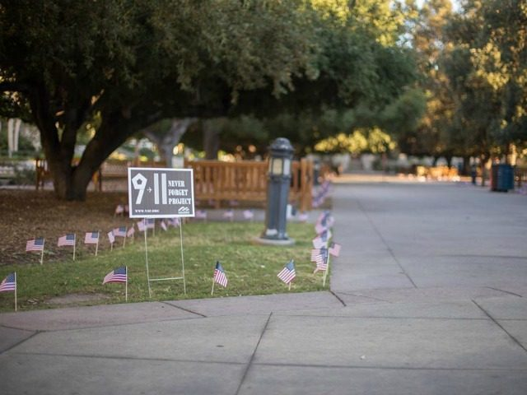
Outrage, questions after 9/11 memorial vandalized at Occidental College

LA Times 9/13/16 by Veronica Rocha

A 9/11 memorial at Occidental College in Eagle Rock was vandalized, members of the Occidental College Republican Club said.
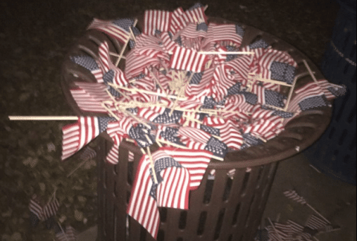
Nearly 3,000 flags planted around Occidental College to remember the victims of the 9/11 terrorist attacks were vandalized over the weekend, provoking outrage and questions on the Eagle Rock campus and beyond. The incident prompted a flurry of statements by student groups, as well as a pledge by university administrators to investigate the incident. Members of the Occidental College Republican Club discovered the destruction early Sunday as well as fliers that “shamed the victims of 9/11,” they said. The fliers, which displayed the image of the two World Trade Center towers, included the message: “R.I.P. The 2,996 Americans who died in 9/11. R.I.P. the 1,455,590 innocent Iraqis who died during the U.S. invasion for something they didn’t do.” “This is beyond politics, this is about those lives that were so tragically taken,” the club said in the statement on Facebook.
“Freedom of speech is protected by the 1st Amendment,” Erica O’Neal, acting dean of students, said in a statement. “The right and freedom to debate complex, contentious issues and disagree with each other is fundamental to what we do at Oxy. At the same time, we may not express ourselves in ways that prevent others from engaging in protected speech.” O’Neal said the college does not know who committed the vandalism, but said that disciplinary actions will be taken once that is determined.
Students placed 2,997 small flags in the campus’ quad Saturday night in preparation for the 15th anniversary of the terror attacks, according to the Republican Club, which sponsored the memorial. The Sept. 11, 2001, attacks claimed the lives of 2,977 victims. The 19 hijackers were also killed. About 1 a.m. Sunday, 15 students found some flags had been broken and others were tossed into the garbage. Students worked quickly to restore the display. According to the club, campus security stood guard after the vandalism.
The club had alleged that four students walked up to them and broke flags in front of them. “When we confronted them, those cowards got away as fast as they possibly could,” the club said. “We had thought the storm had passed, however, we were very wrong.” Later, hundreds of flags were kicked and others were smashed and thrown into the trash, the club said. “Of course, we put them back in the ground,” the club said. “We ask that all students respect the memorial for the remainder of its time in the quad. If you try to destroy it, we will rebuild it.”
Max Woods, who organized the event, said Sunday’s memorial was the first display the club had ever attempted for 9/11. The club has reported the vandalism only to campus officials and security, he said. “This was an attack directed at the memorial, I believe, not on the club,” he said. “The public is outraged over the disrespect shown towards the victims of 9/11.”
The incident has triggered a heated debate on campus over the use of the U.S. flag as a memorial symbol. One student group, Coalition at Oxy for Diversity and Equity, posted a statement on Facebook saying, “We were concerned by the complete disregard for the various peoples affected by this history.” “When this institution allows thousands of American flags to be placed in the center of campus, it speaks volumes to the students that have lived their lives under the oppression of this flag. From Native students whose land was stolen to undocumented students who live in fear of deportation to black students who see their communities destroyed by state-sanctioned murder, this school is saying your fear and trauma do not matter here.”
Students, they said, were confused by the display and asking about its purpose. “This is not a critique of desiring to remember the fallen, this is a critique of failing to comprehend who, or what, has been lost,” the group said. “To this end, we wanted to provide more information and more context in order to center the actual lives and individuals affected by 9/11 rather than simply placing a symbol of one nation.” A poem and signs, including one addressing the number of Iraqis killed since 9/11, were posted throughout the quad “to more deeply remember the event that occurred on 9/11 as well as the lives that were lost within and outside of the United States as a result of those attacks,” the student group said. The group did not respond to a request for comment Monday.
Occidental Students United Against Gentrification shared the student group's message on Facebook with the statement: “We have no tolerance for stolen land, colonizers, oppression, genocides, xenophobia, and/or erasure of culture/people (aka U.S. nationalism).”
Occidental College later sent a statement to students and faculty, saying the display was planned and registered with the school’s Office of Student Life. Campus officials said the college’s Office of Student Conduct is investigating the vandalism. In her statement, O’Neal cited a section of the student handbook that reads: “Occidental College imposes on students, faculty members, administrators and trustees an obligation to respect the dignity of others, to acknowledge their right to express differing opinions, and to foster and defend intellectual honesty, freedom of inquiry and instruction, and free expression both on and off campus.” “Vandalism or other acts that substantially interfere with the rights of others to engage in protected speech violate the College’s Student Code of Conduct and the spirit of this institution,” she said. “Let us work together to find ways to express ourselves and build a community founded on respect.”
Questions to Answer & Discuss:
- What should be done in the above situation to honor the fallen and protect the rights of people to express themselves?

