CWA Class Notes
March 29, 2016 Unit: Terrorism – How should the USA respond to global terrorism?
EQ: What is terrorism and how were the 9/11/2001 attacks an example of it?
Complete the “Four Corners Graphic on the word “terrorism” | 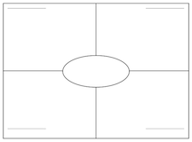
Photos of NYC on Sept 11, 2001:  -Describe the image you received?  -What is most compelling about it?  -Write a caption, thought bubble or statement call-out for the photo | -  -  -
Complete the Gallery Walk, describe the three most compelling photos & write a reaction statement for each: | Description Reaction  1.  2.  3.
Summarize by answering the above EQs in paragraph form:

