CWA Class Notes
September 13, 2016 Unit: Terrorism – How should the USA respond to global terrorism?
EQ: What is terrorism and how were the 9/11/2001 attacks an example of it?
Complete the “Frayer” model on the word “terrorism” | 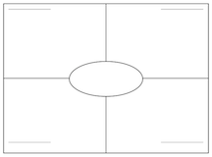
Complete the Gallery Walk, describe the three most compelling photos & write a reaction statement for each:  Picture Number & Description | Reaction statement
Summarize by answering the above EQs in paragraph form:

