HUG Chapter 1: Maps – Glendale Street Names [Source: Glendale News-Press 06/30/2018, Katherine Yamada]
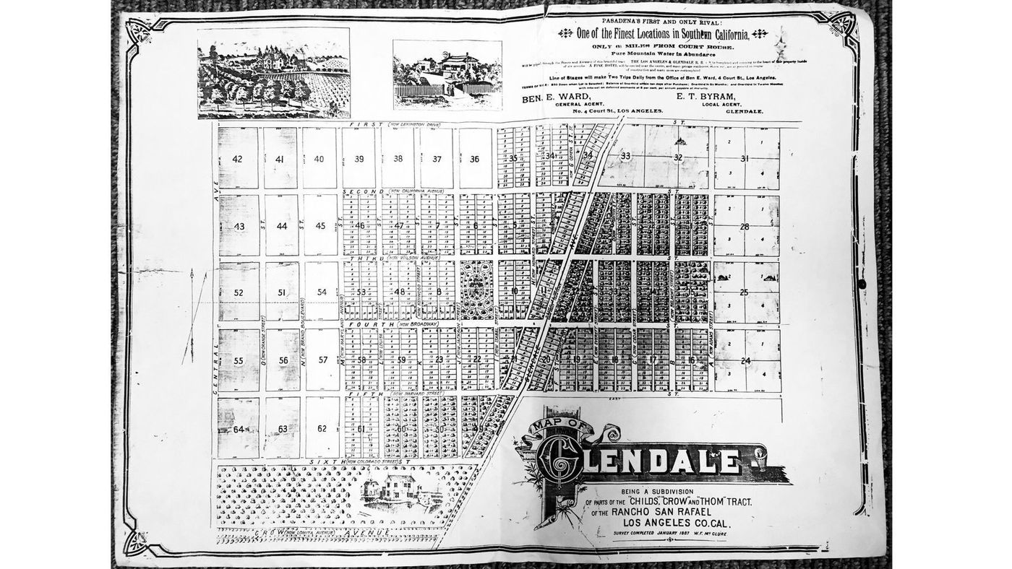
When Glendale was laid out in 1887, letters of the alphabet were given to streets running north and south. There were only a few streets: from A to O. Numbers designated the east and west streets: First through Sixth, according to the “Glendale Area History” book.
When L.C. Brand arrived, he acquired control of a huge swath of land, including N Street, with plans to bring the Pacific Electric railway to that street. Brand was a prime force in our city’s growth. He had a hand in a bank, a country club as well as telephone, water and light companies. Through his influence, N Street was renamed Brand Boulevard. It wasn’t until 1918 that downtown streets were named as they are today. A Street became Adams and O Street became Orange Street and so on.

Numbered streets also received names: First became Lexington Drive, Second became California. Third became Wilson. Yes, Woodrow Wilson was president at the time. Fourth became Broadway. Fifth is now Harvard, and Sixth is Colorado. Residential streets were named by their developers. Since Brand controlled so much land, he had a lot of sway.
According to a series of Glendale News-Press articles in 1975, Louise Street was a tribute to Brand’s wife, Louise, and Randolph, Dryden and Stocker streets were all named for his brothers-in-law. M Street, also renamed by Brand, honored a flourishing romance. One of Brand’s tract managers had a daughter named Mary. She was engaged to a young man named Land. Brand combined their two names and the street became Maryland Avenue.
The earliest residents in the area were acknowledged with a street named Osceola, according to the News-Press articles.

Many of the streets appeared on the earliest regional maps, reflecting the area’s Spanish heritage. They included Alameda Avenue, Canada Boulevard (as in the road to the old La Cañada rancho), Lomita Avenue, San Fernando Road and Sonora Avenue. Newer streets with a Spanish connection are Coronado, Cortez and Naranja drives, along with Glorietta Avenue. Don Jose Drive, and all the streets which begin with Verdugo, carry forward a long association with the Verdugos, who claimed this area for their own in the 1780s. Native oaks are well recognized by streets such as Oak Circle, Oak Glen, Oak Knoll and Oakmont Drive.

Prominent residents often had streets named for them: Barnes Circle for a former mayor, Herman E. Barnes; Beaudry Boulevard, for Prudent Beaudry, who once owned 1,700 acres including the famed Eagle Rock; and Ross Street for state supreme court justice and landowner Erskine M. Ross. Historic events were also recognized, such as when Crescent was changed to Victory Boulevard after World War I.

To conclude this brief overview of Glendale street names, let’s not forget Zinnia Lane, which originally carried off storm water. When it was paved and turned into a street, city officials sought a name starting with a letter at the end of the alphabet. Someone mentioned zinnias and that’s what it became.

Many thanks to my friend Marilyn Chrisman who, several years ago, brought me a list of street names and their origins as taken from the 1975 News-Press series. It’s been a valuable resource.

Q: Why did the original city organizers use a grid based on numbers and letters to designate streets?

Q: Describe the changes in naming streets as Glendale developed. What did these changes reflect?

