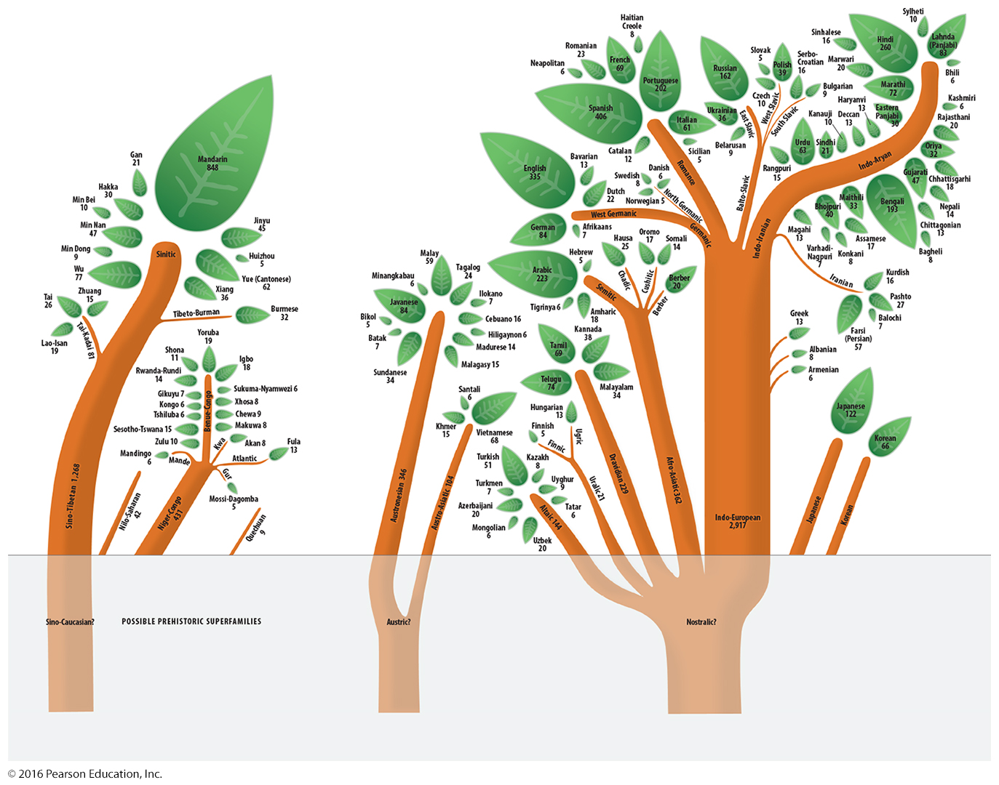
Human Geography: Chapter 5 Languages
Notes:

