Human Geography: Chapter 4-5-6 Culture, Language & Religion
Analyze the map below and write a GIST statement [20-25 words] in the chart provided that summarizes the global distribution of the world’s major religions.
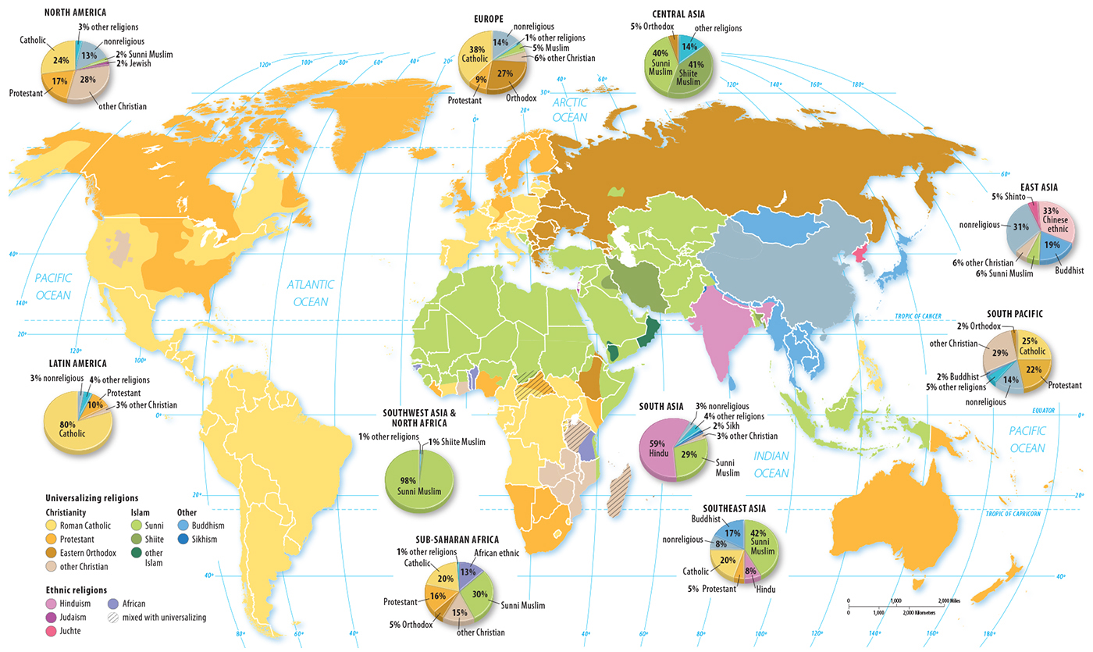

Human Geography: Chapter 6 Global Religion Distribution
Analyze the adjacent pie chart. Write a GIST [20-25 words] that summarizes the global distribution of religion:
Global Region | GIST Statement
North America
Latin America
Europe
Southwest Asia & North Africa
Sub-Saharan Africa
Central Asia
South Asia
Southeast Asia
East Asia
South Pacific
