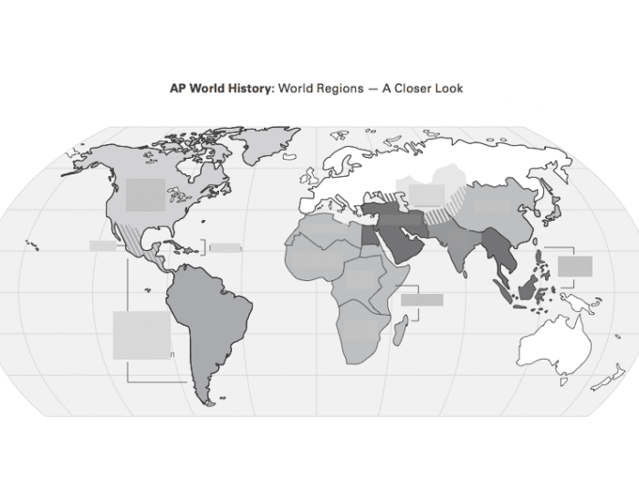
AP Human Geography: Global Regions Review – Identify the main global regions, major city (or two) within the region, key country (or two), and multiple facts (in bullet point format) that make it unique in some way based on our units of study: Population & Migration, Cultural Patterns, Political Organization, Agriculture & Land Use, Industrial & Economic Development, Cities & Urban Land Use

